MVP Modules


Functional Requirement Note

Unified Scholarship Interface (USI)

Table of Contents
Purpose 2
Components of the Scholarship Model 2
Design Philosophy 2
Product Modules 2
Modules Inclusions and Priority in MVP 3
MVP Modules 4
Scheme Management 4
Candidate/Institute Management 12
Application Management 15
Scheme Disbursement 19
Grievance Redressal 19
Public Pages 19

Purpose
To create an integrated, technology-driven platform that streamlines discovery, access, application, verification, and disbursement of scholarships improving coverage, efficiency and transparency.

Components of the Scholarship Model

Design Philosophy
The design of the product should enable the various state governments to install and configure the product in their ecosystem seamlessly. Below are the principal components of design philosophy:
- Configurable scholarship module through which different types of scholarship can be defined
- Configurable eligibility and disbursement modules
- Both cloud and on-prem hosting support. On-prem hosting within state’s Local data center (on-premise) would enhance data protection and compliance management
- Ability to map the students’ educational journey to enable administrative efforts in ensuring benefits to all eligible students
- Allow for auto - renewal process which will remove burden to application from students every year
- Dashboard and reports bundled as part of the product

Product Modules
There will be 8 modules of the product to cover (excluding Front End UI/UX) - Login Flows, Application and Disbursement flows, Grievance Redressal and Monitoring. These are as below:
- Scheme Management (Adding and Modifying Schemes)
- Candidate Management (Login Flows & Candidate Profile)
- Application Management
  - Application Flow
  - Eligibility Engine (Scheme wise Custom eligibility rules and documentation)
  - Application Verification (Custom application flows for different schemes)
- Scheme Disbursement (Output of verified beneficiaries for payment)
- Grievance Redressal (Grievance ticket and resolution system)
- Admin Module (Scheme Configs and Access controls)

Apart from above core modules, below elements will also be part of USI product design
- Monitoring & Reporting Dashboard
- All Publics pages of the portal
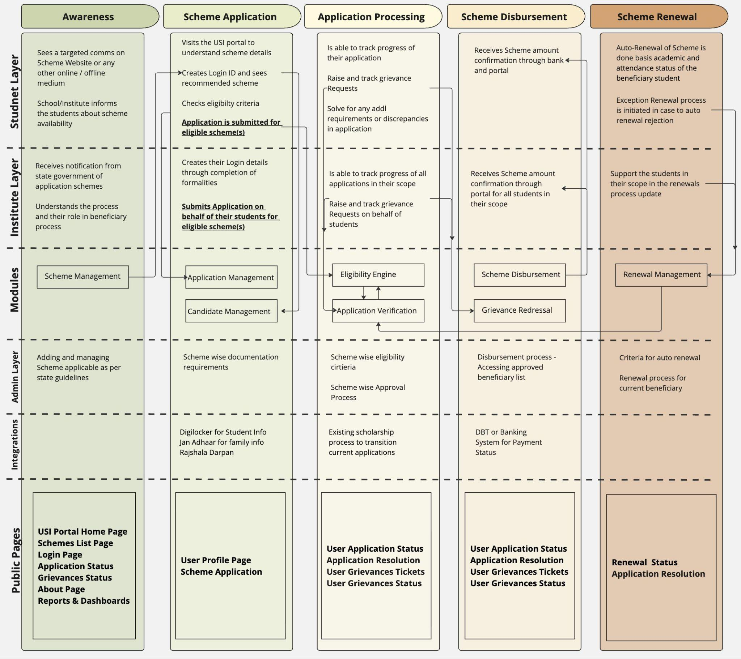

Modules Inclusions and Priority in MVP
Module Name | Sub-Modules | Priority
Scholarship Management | Adding and Modifying Schemes | 1
Application Management | Eligibility Engine Config  Application Verification Module | 2
Disbursement Module | Output for govt in desired format of verified beneficiaries | 3
Candidate Management | Login Flows  Basic Profile (demographics, education, family info) | 4
Monitoring & Reporting Dashboard | Beneficiary Dashboard  Basic Filters | 5
Grievance Redressal | Grievance ticket system  Existing Grievances Management | 6
Admin Module | Manage access control | NA

MVP Modules
The MVP will include the modules defined in the previous section. The detailed functionalities needed in each module will be documented below.

Scheme Management
This module enables the state management to add, remove and manage various student scholarship schemes that they plan to make available to the student beneficiaries. It will include below functionalities:
- Addition of Schemes Incl Budget Allocation
- Defining Documentation Requirements
- Defining Eligibility rules for the scheme
- Scheme Approval Workflow
- Deletion of Schemes

Addition of Schemes
- Step 1: Scheme Basic Details
  - Scheme Name
  - Scheme Objective/Description
  - Applicable Cohorts (TBD) - Select combination of the below fields basis scheme
    - Age group - configurable upper and lower age limit
    - Gender - pre configured set of option to be selected (Male, Female, Transgender)
    - Income group - Creator can choose from below available income
      - Less than 5000,
      - 5000 to 20000,
      - 20000 to 50000
      - 50000 to 1 lac
      - 1 Lac to 2 lacs
      - 2 lacs to 4.50 lacs
    - NSFA Status
      - BPL
      - State BPL
      - APL
      - Antyodaya
    - Custom Cohort Field - Ability to create custom fields
  - Scheme Start and End Date
    - The start date must always be earlier than or equal to the end date
    - Start & end dates must lie within the financial year (April–March) unless flagged as a multi-year scheme.
    - Date format (DD-MM-YYYY)
  - Applicable Institutions
    - List of institutes to be uploaded in separate doctype table
    - Creator should be able to select ‘All’ or specific institutes for the scheme
    - Creator should also be able to add new institutes in the list
  - Scheme Type: there will be categories of center and state sponsored schemes and also where state may add more budget to center based schemes
    - Central Govt
    - State Govt
    - Central-State (with Addl budget by state)

- Step 2: Scheme Impact
  - Define Total Scheme Budget: Creator to input total allocation
    - Define annual or multi-year
    - Define department from which budget is to be taken
  - Scheme Categorization: Any scheme should be categorised correctly so that we can use these tags for analytics and reporting
    - Merit-based
    - Income-based
    - Category - General/SC/ST/OBC/SPC/MBC
    - Minority - Religion based (muslim/sikh/jain/christians)
    - Special Groups - Region based (J&K), Occupation based (ex army), Survivor groups
    - Special Category
      - Disability support
      - Destitute Women
      - Children in Need of Care & Protection (Palanhaar/children homes)
      - Children in Conflict with Law

- Step 3: Quota Management Features:
Ability to allocate budgets and distribution based on scheme design and target beneficiaries.
    - Allocation Dimensions Supported
      - Geographic → State / Division / District / Block / Institution-level
      - Demographic → Age limit, Gender group
      - Social Categories → As mentioned in Step 1
      - Economic → Family income bands as mentioned in Step 1
      - Special Categories → As mentioned in Step 1
    - Allocation Basis
      - Single-Dimension (e.g., district-wise only, or gender-wise only).
      - Multi-Dimension Hierarchical (e.g., 50% district-wise → within each district, 30% girls, 20% SC, etc.)
    - Enter Allocation Rules
      - % Quota Mode: e.g., 40% Girls, 15% SC, 10% Disabled.
      - Absolute Number Mode: e.g., ₹10 Cr out of ₹50 Cr for Female students.
    - Define Carry-Forward Rules
      - Lapse → unused funds/slots vanish after scheme ends.
      - Redistribute → leftover capacity flows to other pools defined
    - Define Conflict Resolution Logic
      - If a student falls into multiple categories (e.g., SC + Female + Disabled), use priority as defined from options below:
      - Priority Order (predefined by state, e.g., SC > Disability > Female).
      - Best Benefit Rule - assign to whichever quota gives
        - L1 - Amount of disbursement
        - L2 - Duration of scheme benefit
        - L3 - highest chance of sanction
- Cap per Beneficiary: Define maximum disbursal per student (per application)

Defining Documentation Requirements
- Document Checklist Configurator: Officials can specify
  - Mandatory / Optional documents
  - Family Related (income certificate, caste certificate, etc)
  - Student Related (Domicile, marksheet, attendance, disability certificate, etc.)
  - Conditional Documents (e.g., "Income certificate required only if family income > INR 2.5 Lakh")
- Integration with System (DigiLocker / State Repositories)
  - Define which documents can be auto-verified
  - Documents that require manual upload.
  - Physical verification requirements for specific documents
- Upload/Submission Rules
  - Acceptable File formats
  - Define max file size

Defining Eligibility Rules for the Scheme
We already have the Eligibility Engine module built by Indus Action and will be plugged into the Unified Scholarship Portal. The engine has two parts:
- Decision Tree → Runs hard rules (age ≥ 18, category = SC, income ≤ threshold, etc.).
- Proximity Score → If some required attributes are missing, the engine calculates closeness (e.g., 2/3 eligibility signals present) and flags what’s missing.

When a new scheme is added/modified:
- Admin UI Needed (To be built: frontend layer for scheme managers):
  - Add rules visually (e.g., age ≥ 18, caste = SC/ST, income ≤ ₹2,50,000).
  - Define mandatory fields (e.g., income certificate, caste certificate).
  - Save rules into the Eligibility Engine by mapping them into JSON payload schemas.
- Backend Process
  - Convert UI-defined rules into the JSON schema expected by the Eligibility Engine API.
  - Store mapping in the scheme config DB (so every scheme has its criteria linked to the engine).
  - Allow versioning (so if criteria changes, older applications still run on the earlier rule set).

We will need to build the Admin UI for Rule Builder for each scheme as below:
- Visual Rule Creation
  - Drag-and-drop or form-based rule builder.
  - Supports AND/OR logical operators.
  - Nested conditions (e.g., Category = SC/ST AND Income ≤ ₹2.5L).
- Attribute Selection
  - Pre-loaded list of attributes available from system (e.g., Age, Gender, Caste, Income, Disability, Academic %).
  - Admin can pick an attribute → define condition → assign value.
- Condition Types Supported
  - Numeric (≥, ≤, =, between).
  - Text/String (=, contains, in list).
  - Boolean (true/false).
  - Multi-select (Category ∈ {SC, ST, OBC}).
- Document Mapping
  - For each rule, admin can mark supporting documents required (e.g., caste certificate, income certificate).
  - System enforces document upload at candidate application stage.
- Rule Grouping
  - Admin can create groups of rules:
    - Core Eligibility Rules (mandatory).
    - Additional Preference Rules (e.g., female students get extra consideration)
- Preview & Testing
  - Real-time JSON preview of rule definition.
  - Test input data to see eligibility outcome before publishing.

Rule Builder Panel
- Dropdown: Select Attribute (Age, Gender, Caste, etc.)
- Dropdown: Condition Operator (≥, ≤, =, contains, etc.)
- Input: Value (e.g., 18, SC, ₹2.5L).
- Checkbox: Document Required? (Yes/No).
- Button: Add Rule.

Logical Grouping Panel
- Option to group rules with AND / OR.
- UI allows nested groups (collapsible cards).
- Example:
(Category = SC OR Category = ST) AND Income ≤ 250000


Rule Summary View
Tabular list of configured rules:
Attribute | Operator | Value | Document Required | Group
Age | ≥ | 18 | No | Group A
Income | ≤ | 250000 | Yes | Group A
Category | IN | SC, ST | Yes | Group B

JSON Preview
- Auto-generated JSON output (read-only) mapped to Eligibility Engine schema.
- Example:
{
"rules": [
{ "attribute": "age", "operator": ">=", "value": 18 },
{ "attribute": "income", "operator": "<=", "value": 250000, "document": "income_certificate" },
{ "attribute": "category", "operator": "IN", "value": ["SC", "ST"], "document": "caste_certificate" }
],
"logic": "(A AND B) OR C"
}


Testing Sandbox
- Input form to enter sample applicant data.
- Button: Run Test → Displays: Eligible / Ineligible / Missing Fields.
- Helps admins validate rules before publishing.

EE Workflow
- Admin Opens Scheme → Eligibility Rules Tab.
- Adds conditions one by one using the Rule Builder Panel.
- Groups rules using AND/OR logic.
- Maps required documents.
- Tests rules with sample data (Testing Sandbox).
- Saves draft or publishes ruleset.
- The system stores rules in DB + syncs to the Eligibility Engine.

Technical Considerations
- Backend must translate UI inputs into JSON schema for Eligibility Engine.
- Support multi-language labels (Hindi/English/etc.) for attribute names & error messages.
- Rules stored with version ID linked to scheme.
- API endpoints:
  - POST /eligibility-rules → Save rule set.
  - GET /eligibility-rules/{schemeId} → Fetch current/previous rules.
  - POST /eligibility-rules/test → Run test data against rule set.

Scheme Modification Use Cases and Workflows
- Scheme Period Extension / Foreclosure
  - Extension of Scheme
    - Officials can extend the validity period of a scheme by changing the end date mentioned on the scheme
    - Extended period reflected in candidate application dashboard and public portal.
    - New end date must be greater than the old end date.
  - Foreclosure of Scheme
    - Ability to close a scheme before its scheduled end date
      - Add ‘Foreclose’ Option among all sanctioned and live schemes
      - Foreclose → Reason for foreclosure from Dropdown → Submit for approval
    - Pending applications move to “on-hold” or “rejected” status with reason codes.
    - Notification to applicants and district nodal officers.
    - New end date cannot be earlier than today if applications are still active,
  - Workflow:
    - Submit change →
    - Review by nodal officer →
    - Finance approval (if budget changes) →
    - Publish update
  - Notifications: Notify students and schools about new dates on the website alerts section
  - Audit Log: Tracks old dates, new dates, budget changes, approvers, and reasons.

- Scheme Budget Changes
  - Increase in Budget
    - Additional funds can be allocated if demand exceeds supply.
    - Can be applied to
      - Specific Schemes
      - All state-wide schemes
      - Geo-specific or category-specific schemes
    - Add ‘Add Budget’ Option among all sanctioned and live schemes
    - Add Budget → Reason for increase from Dropdown → Submit for approval
  - Reduction in Budget
    - In case of fiscal constraints, the scheme budget may be reduced mid-cycle.
    - System auto-calculates impact on pending/approved applications.
    - Can be applied to
      - Specific Schemes
      - All state-wide schemes
      - Geo-specific or category-specific schemes
    - Add ‘Slash Budget’ Option among all sanctioned and live schemes
    - Slash Budget → Reason for increase from Dropdown → Submit for approval
  - Workflow:
    - Submit change →
    - Review by nodal officer →
    - Finance approval →
    - Publish update.
  - Reconciliation: Utilized vs. allocated vs. revised budgets tracked in real time.
  - Notifications: Auto alert to districts and students about revised disbursal status on the website alerts section.
  - Audit Log: Budget changes, approvers, and reasons.

- Scheme Quota Distribution
  - Change in Allocation Basis
    - Switch from single-dimension to multi-dimension (e.g., add caste quota mid-cycle).
    - The system recalculates only the remaining budget, leaving the utilized budget untouched.
  - Reallocation Across Dimensions
    - Example: Reduce District Jaipur allocation from ₹5 Cr → ₹4 Cr and transfer to District Alwar.
    - Example: Reduce SC quota from 15% → 10%, reassign difference to General category.
  - System Logic:
    - Maintain Original Matrix + Revised Matrix.
    - Pending/New applications are reassessed based on new rules.
    - Approved applications are frozen under the old rules.
  - Adjust Quota % or Absolute Numbers
    - Example: Increase Girls quota from 40% → 50%.
    - System recalculates pending applications → how many more can now be admitted.
  - Carry-Forward Rule Change
    - Example: Change from “Lapse” to “Redistribute.”
    - At scheme closure, unused quota gets reassigned.
  - Conflict Resolution Update
    - Example: Switch from Priority Rule to Best Benefit Rule.
    - Simulation required before applying change (so admin sees new beneficiary impact).

- Key Engineering Notes
  - Data Structures to Maintain
    - Scheme_Master → Scheme metadata (name, dept, period, type).
    - Scheme_Distribution → District-level budget matrix.
    - Scheme_Quota → Category-level quota matrix.
    - Scheme_Versions → Version history with change logs.
  - Version Control
    - Every modification = new version.
    - Maintain link to parent version.
    - Applications tagged with scheme version at time of submission.
  - Simulation Engine
    - Mandatory for distribution & quota changes.
    - Runs “what-if” analysis before publishing modifications.
  - Approval Workflow
    - All modifications must pass through the same Draft → Review → Approval pipeline.
    - Finance Dept approval required for budget & distribution changes.

Approval Workflows for New Scheme and Modification Requests
Since scholarship schemes involve multiple departments (Education, Social Justice, Tribal Affairs, Finance), an approval workflow ensures accountability and prevents unauthorized scheme activation.
- Default Stages: Draft → Review → Approval → Publish Workflow
  - Draft Mode:
    - Created by <designated officer> but not visible publicly.
    - Scheme not visible to public or applicants.
    - Drafts saved as in-progress until ready for submission.
  - Review Mode:
    - Reviewing Officer (default = creator’s immediate superior, OR specific officer chosen by name/department/designation).
    - Validate scheme details (eligibility, documentation, distribution logic).
    - Check alignment with state policy and legal framework.
    - Possible Actions:
      - Approve & Forward → moves to Approval Stage.
      - Send Back for Edits → returns to Draft Mode with reviewer’s comments.
      - Reject Draft → archived, cannot be reused..
  - Approval Stage:
    - Senior Officer (default = Dept. Secretary or nominated authority).
    - Policy-level approval.
    - Ensures scheme is aligned with department’s strategy and eligibility structure.
    - May review quotas, special groups, and disbursement method.
    - Possible Actions:
      - Approve & Forward → moves to Final Sanction.
      - Send Back → to Review Mode or Draft Mode (depending on issue severity).
      - Reject → scheme archived.
  - Final Sanction:
    - Finance Dept. or Designated Budget Officer.
    - Validate financial provisioning and budget head availability.
    - Cross-check scheme allocations with state treasury limits.
    - Approve fund release cycles (monthly/quarterly/annual).
    - Possible Actions:
      - Sanction & Publish → scheme made visible on candidate portal.
      - Send Back to Approval Stage → if budget clarifications needed.
      - Reject → scheme archived, flagged for revision in next cycle..

- Default Workflow (Hierarchy-Based)
  - Creator → Immediate Superior (Reviewer) → Dept. Secretary (Approver) → Finance Dept. (Sanction).
  - Auto-assigned based on org chart hierarchy maintained in admin system.

- Custom Workflow (Optional Override)
  - At Draft stage, creator can define a custom approval chain, Select specific officer(s) by:
    - Name (from user directory).
    - Department.
    - Designation.
  - If a custom flow is not fully defined, missing steps default to hierarchy.

- Fallback Rule: If custom flow approver is unavailable (e.g., transfer/retirement), system auto-reroutes to default hierarchy.

- Configurable Reviewer and Approval Stages: Schemes may need approval at
  - State level
  - District / Division level

- User Roles access to be given to designated officers
  - Initiator(s)
  - Reviewer(s)
  - Approver(s)
  - Sanctioner(s)

- Digital Signatures / eOffice Integration: For formal approval.
- Audit Trail: Every step logged (who created, who reviewed, who approved, with timestamps).

Deletion of Schemes
- Closed: Allow schemes to be marked as ‘Closed’.
- Dependency Checks: System should not allow deletion if applications exist for that scheme; instead, move scheme to "Closed" status.

- User with permissions can mark the scheme ‘Disposed’ from ‘Closed’ in case it is decided to not be used in future

- User with permissions can bring back scheme by marking it ‘Active’ from ‘Closed’
- Optional: Auto-archive after Expiry: Schemes can be automatically moved to archive once validity end date passes.

Bulk Scheme Creation/Modification
To simplify large-scale data entry and updates, the portal will support bulk upload features for administrators.
- Template-Driven Uploads
  - Predefined CSV/Excel templates with validation columns.
  - Inline help for column definitions (scheme_id, scheme_name, start_date, end_date, eligibility_criteria, etc.).
- Validation Engine
  - System validates data before committing:
  - Mandatory fields check.
  - Rule consistency (e.g., quotas add up to 100%).
  - Data type verification (numeric vs text).
  - Duplicate entry detection.
- Error Handling
  - Upload generates an error report (CSV/Excel) with row-specific issues.
  - Admin can re-upload only the corrected rows.
- Audit & Versioning
  - Every upload tagged with uploader details (user ID, timestamp).
  - Rollback option in case of erroneous uploads.

Notification and Alerts
All notifications for this module are to be shared with internal stakeholders via Email for formal approvals, audit logs as below:
- Scheme Lifecycle Notifications
  - New Scheme Submitted (both one and bulk)
    - Notify scheme admins & reviewers
    - Copy to Creator
  - Scheme Approved & Published
    - Notify all relevant department staff
    - Finance team
    - Creator
  - Scheme Rejected/Returned
    - Notify scheme creator with reviewer remarks.
    - Copy to Reviewer
  - Scheme Foreclosure/Extension Approved
    - Notify all relevant department staff
    - Finance team
    - Creator

- Workflow & Approval Notifications
  - Action Required: Pending Approval → Reminder sent if not acted upon in X days.
  - Escalation Alerts → If pending > SLA (e.g., 7 days), escalate to a higher hierarchy officer.
  - Approval Stages (Reviewed, Approved, Sanctioned): Notify scheme creator once decision each stage is taken.

- Compliance & Monitoring Alerts
  - Deadline Approaching → Alert when scheme closing date is 30 / 15 / 7 days away.
  - Exceeding Budget Caps → If expenditures approach or exceed allocated budget.
  - Policy Compliance Breach → Example: Reserved % for a category not maintained
  - Unusual Application Pattern (fraud detection) → Notify admin if suspicious spike from one district or category.

- Engineering Considerations
  - Configurable Thresholds → Admins should define % utilization triggers.
  - Role-Based Alerts → Only relevant users get notified
  - Escalation Matrix → If action not taken in SLA, escalate automatically. Escalation matrix to be defined in a separate doctype
  - Notification Log & Audit → All alerts stored for audit trail (who got notified and when).
  - Multilingual Support → Notifications should support Regional languages

Admin Module to be configured for Scheme Management Module
Permissions
- Scheme Creation
  - User should be able to create / add new schemes either one by one
  - User should have bulk upload access for adding new schemes
  - User should be able to save scheme creation form as draft
  - User should be able to create eligibility rules for the scheme
- Scheme Eligibility Config
  - Reviewer/Approver (State Officer) → Approve published rules.
  - System Admin → Manage attribute library (which fields are available in rule builder).
- Scheme Modification
  - User should be able to change all scheme configurations in sanctioned / live schemes
- Scheme Deletion
  - User should be able to archive existing schemes
  - User should be able to make archived schemes active again
- Scheme Reviewer
  - Approve or Reject new schemes added in system
  - Approve or Reject existing schemes modification done in system
- Scheme Approver
  - Approve or Reject new schemes added in system
  - Approve or Reject existing schemes modification done in system
- Scheme Sanctioner
  - Approve or Reject new schemes added in system
  - Approve or Reject existing schemes modification done in system

User Roles
- Initiate
- Review
- Approve
- Sanction
- Modification and Deletion

Candidate/Institute Management
This module provides students (beneficiaries) with the ability to log in securely, manage their basic demographic profile, and track the progress of their scholarship applications.

Login Management

Candidate Login
- New Candidate Registration (First Time)
  - Adhaar based Biometric Login
  - Validate candidate using Jan Aadhaar ID + Mobile OTP.
    - Auto-fetch family & individual details from Jan Aadhaar to seed profile.
- Login Options
  - Adhaar based Biometric Login
  - Jan Aadhaar ID + OTP (primary for Rajasthan; Aadhaar or state ID for other states).
  - Optional: Mobile Number OTP + Email OTP (for quick access, linked with Jan Aadhaar database)
- Forgot Password / Reset
  - Mobile and Email OTP-based reset flow.
- Security Controls
  - Limit OTP retries.
  - Device/browser binding (optional in later phases).
  - Auto-logout after inactivity.

Institute Login
- First-Time Registration
  - Institute enters AISHE Code.
  - System verifies with AISHE database API (or pre-uploaded AISHE master).
    - Error message in case the institute is not in the AISHE database. Ask the user to first get that step done
  - Institute Device IP address whitelisting
  - Institute Admin credentials created.
- Institute Login Methods
  - AISHE Code + Registered Mobile/Email + OTP (primary)
  - Username/Password (for institutional admins once registered)
  - Role-based Logins within institute (Admin, Verifying Officer, Nodal Officer).
- Multi-Role Access
  - Admin can create logins for faculty/nodal officers with defined permissions.
- Forgot Password / Reset
  - OTP/email reset tied to registered admin mobile/email.

Profile Management

Candidate Profile
- View & Confirm Pre-Filled Data
  - Pull demographic details from Jan Aadhaar / State DBs.
  - Pre-populated fields (read-only if synced with govt DB).
- Editable Candidate Fields (MVP)
  - Add alternate Mobile number & email (for notifications).
- System-Synced / Verified Fields (read-only)
  - Name, Gender, Date of Birth.
  - Address (temporary/permanent, if not locked by Jan Aadhaar sync).
  - Bank account details (for DBT disbursal).
  - Caste/Category (SC/ST/OBC/General/MBC).
  - Income Group (from ration card/Jan Aadhaar).
  - Disability Status (if recorded in state DB).

Institute Profile
- Pre-Filled from AISHE Database
  - Institute Name, Type (Govt/Private/Aided), Location, Affiliation University, Courses.
  - Basic details read-only (system-synced with AISHE).

- Editable Fields (Institute can update)
  - Nodal officer details (Name, Mobile, Email).
  - Bank account details for reimbursements (if any).

- Role/Workflow Setup
  - Admin assigns institute roles (Approver, Verifier, Viewer).

Application Status Page

Candidate Application View
- List of All Applied Schemes
  - Show scheme name, academic year, application ID.
- Status Tracking (Application Workflow)
  - Submitted → Under Verification (Institute/District) → Sent Back → Approved → Disbursed → Rejected.
  - Display reason codes for rejection/hold (e.g., missing document, eligibility mismatch)
  - Candidate reopens application → updates/corrects info → re-submits.
  - System maintains version history (original + corrected).
- Progress Tracker
  - Visual timeline for each application (similar to courier tracking UI).
- Download / Print Acknowledgement
  - Candidate can download submitted application receipt.
- Notifications
  - Alerts for key updates (application submitted, sent back, verification complete, disbursement done).
  - Available on dashboard + SMS/Email.

Institute Application View
- View Pending Applications
  - List of students who selected this institute during application.
  - Details pre-filled from candidate portal.

- Verify Academic Details
  - Admission/Enrollment Number.
  - Course, Year, Attendance % (if required).
  - Marksheets (via DigiLocker / uploaded).

- Approve / Reject / Send Back (to be detailed out in application management)
  - Approve → Moves to District/State for further processing.
  - Reject → Candidate notified with rejection reason code.
  - Send Back → Candidate allowed to resubmit missing documents.

- Dashboard for Institute
  - Pending applications
  - Approved applications
  - Rejected applications

- Audit Trail
  - Time-stamped verification logs.
  - Officer name & action recorded for accountability.

Integration Needed
- Digilocker (PII and Educational details)
- Adhaar (Identification verification)
- Jan Adhaar (caste, income, residential Certificates)
- PFMS (for disbursement status)
- Communication (SMS. Email. Whatsapp)
- Optional: NPCI

Engineering Considerations
- Data Integration
  - Pull demographics from Jan Aadhaar / State DB.
  - Status updates from Application Management Module.
  - Pre-load AISHE institute master data: Validation API (if live integration possible)
  - Ensure the institute cannot modify student demographic details — only academic verification fields.
- MVP UI Simplicity
  - Keep workflows mobile-first (majority of students in rural Rajasthan/Meghalaya will use smartphones).
  - Minimal data entry, maximize pre-fill from govt databases.
- Auditability
  - Log of candidate logins & profile updates.
  - Application status history preserved.
  - Logs stored for future audits (who verified, when, decision).

- RBAC (Role Based Access Control)
  - Institute Admin → Manages roles, full access.
  - Nodal Officer → Verifies applications.
  - Viewer → Can see status but not act.

Application Management
This module governs the end-to-end journey of a student’s application for a scholarship scheme, including eligibility checks, verification, approvals, and pre-disbursement readiness.

Eligibility Engine Worflow

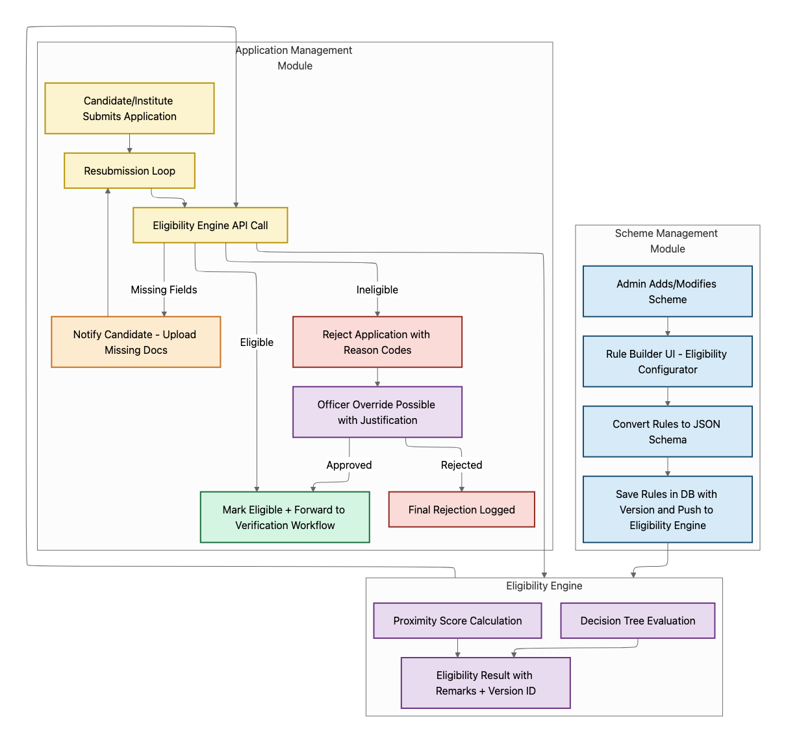

When a candidate/institute submits an application:
- Step 1: Application
  - The candidate fills in personal, academic, income, caste, and other required details.
  - Inline validations (mandatory fields, date format, etc.) happen at form level.
  - Application data (demographics, income, caste, documents, academic details) is packaged into a JSON payload.
- Step 2: Payload sent to Eligibility Engine API:
- Endpoint: /evaluate
- Engine evaluates against the scheme's rule set (decision tree + proximity scoring).
- Step 3: Engine response determines flow:
  - ✅ Eligible → Application forwarded to Verification stage.
  - ⚠️ Proximity/Missing Fields → Application flagged. Candidate/institute prompted to upload missing data/documents.
  - ❌ Ineligible → Candidate shown reason (from output) in plain language.
- Step 4:
  - All decisions + proximity scores logged in system DB for audit.
  - If marked ineligible but candidate disputes:
    - Candidate may file a clarification (attach new docs).
    - Officer at institute/district level can override engine output (must add justification).

- Step 5 – Workflow Continuation → Once eligibility validated:
  - Application tagged with eligibilityStatus.
  - Passed → moves to verification and approval workflow.
  - Failed → either closed or kept in correction loop until resolved.

Data Flow
- Applicant data stored in Application DB.
- Eligibility Engine consumes payload → returns status.
- Result stored back in DB with:
  - eligibilityStatus (Eligible, Ineligible, Pending Clarification).
  - eligibilityVersion (ruleset version applied).
  - eligibilityRemarks (from engine output).

Notifications & Alerts
- Candidate: SMS/email when eligibility fails or clarification required.
- Institute Reviewer: Alert if candidate resubmits after eligibility failure.
- Admin: Report dashboard on # of rejected apps by eligibility engine.

Roles & Permissions
- Candidate/Institute: Can view eligibility outcome + reasons.
- Verifier/Officer: Can override results with justification.
- Scheme Admin: Manages eligibility rules (via Rule Builder UI).

New Application Flow
This is the core application processing workflow, moving from candidate submission → institute verification → govt approvals → ready for disbursement
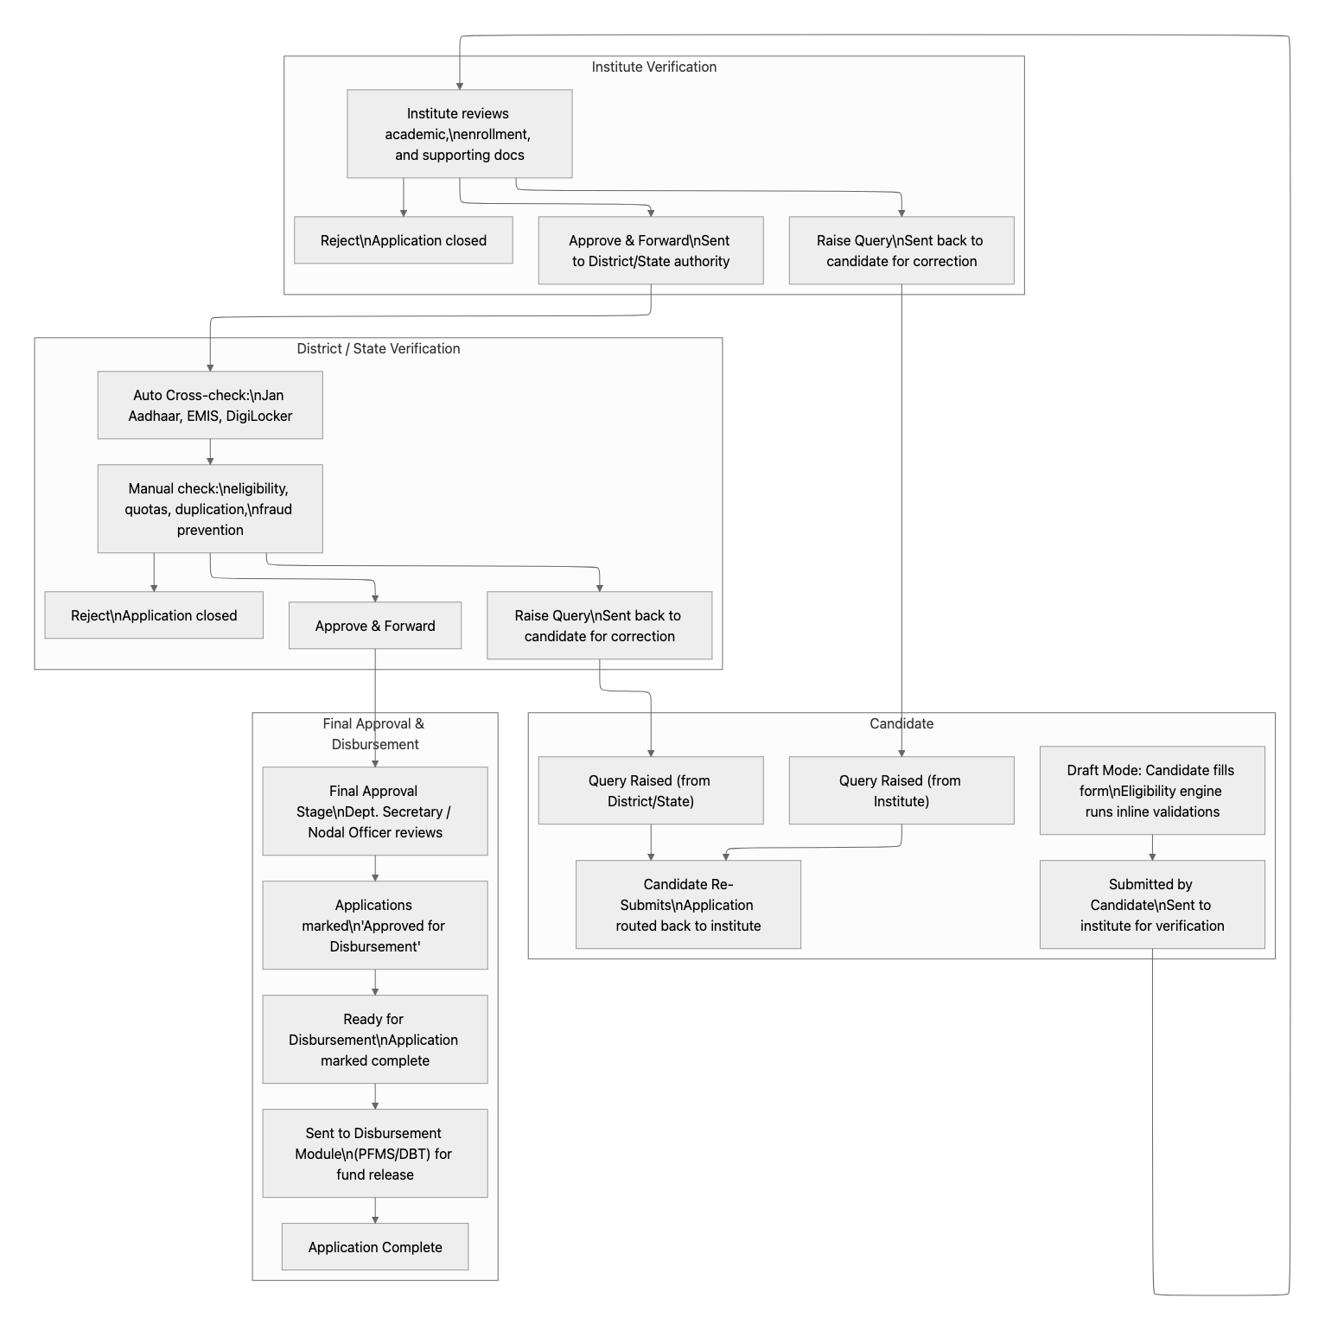

Stages | Candidate Action | Institute Action | Govt Action (District/State) | Outcome
Draft | Fill/edit form | – | – | Draft saved
Submit | Final submit → lock application | Receives pending applications | – | Eligibility Engine API run
Eligibility Engine | Clarification or additional documentation | – | Manual Overrides during verification stage | Sent to institute
Institute Verification | Wait for status | Approve / Reject / Query | – | Verified/Rejected/ Correction
Correction / Re-Submission | Update details + re-submit | Re-review | – | Back to verification
District/State Verification | Wait for updates | – | Approve / Reject / Query | Verified
Final Approval | Wait for decision | – | Dept. Nodal Officer final approval | Approved
Ready for Disbursement | Status visible on dashboard | – | Finance marks eligible for DBT | Sent to disbursement
Disbursed | Funds credited, notified | – | PFMS/DBT syncs status | Closed

Candidate Application Flow
1. Draft Stage (Candidate Side)
- System Behavior:
  - Candidate logs in (via Jan Aadhaar / Mobile OTP).
  - Sees a list of available schemes (filtered by basic eligibility rules → age, category, gender).
  - Selects a scheme → application form opens.
- Application Form Window:
  - Pre-filled fields (from Jan Aadhaar, EMIS, Digilocker):
    - Name, DOB, Gender, Caste/Category, Family Income Group.
  - Editable fields:
    - Contact details, bank account, current course, marks, supporting docs (upload).
  - Real-time eligibility engine checks mandatory rules:
    - If rule fails, field is highlighted with error tooltip.
    - Candidate cannot proceed until corrected.
- Actions Available:
  - Save Draft (auto-save enabled).
  - Submit Application (locked for editing after this).
2. Submission Stage
- Application is timestamped, locked, and routed to the tagged institute (based on course/school selection).
- Candidate dashboard shows:
  - Current State: Application Submitted
  - Next Step: Awaiting Institute Verification.
- The candidate receives SMS/email confirmation with Application ID.

3. Institute Verification Stage
Login & Dashboard: When Officer logs into Institute Portal.
- Sees Application Inbox:
  - Filters: Pending / Verified / Sent Back / Rejected.
  - Search by Student Name, Application ID, Course.
  - Bulk selection checkboxes.
Application Detail View: When officer clicks an application:
- Student Details Tab
  - Personal: Name, DOB, Gender, Caste, Category.
  - Income group (auto-fetched from Jan Aadhaar / ration card).
  - Special categories (disability, orphan, minority, ex-servicemen).
- Academic Details Tab
  - Course, Year, Enrollment No.
  - Previous marks (auto-fetched from EMIS/Digilocker if available).
  - Uploaded bonafide certificate, TC, mark sheets.
- Bank & Disbursement Tab
  - IFSC, Account No. (auto-verified via PFMS integration).
- Eligibility Check Tab
  - Eligibility engine output: Green (Pass)
  - Yellow (Conditional/Need Manual Checks) → with fields to be checked
  - Red (Reject) → with reasons for rejection
Verification Actions Available
- Approve & Forward → Application moves to District/State.
- Reject → Provide reason code (e.g., Wrong Caste Certificate, Not Enrolled).
- Send Back for Clarification:
  - Popup: Select reason type (e.g., Incomplete Bank Details, Document Missing).
  - Optional comments box.
  - Candidate notified immediately via SMS/email.
- Bulk Verification Mode:
  - Officer can select multiple applications → view summary grid (Name, Enrollment No., Course, Eligibility Status).
  - Approve/Reject in bulk (requires entering remarks per batch).
System Behavior After Action
- All actions are time-stamped.
- Candidate dashboard updates status instantly.
- Correction workflow (if Send Back chosen) creates a new editable version for candidate.
4. District/State Verification Stage
Dashboard:
- Applications routed from institutes appear here.
- Filters: Scheme, District, Institute, Application Status.
- Searchable list with candidate details.
Application Window (Extended View):
- All fields from institute verification stage.
- Institute Verification Logs: Who approved, timestamp, remarks.
- Quota/Distribution Engine Output:
  - Example: 50% female quota → remaining seats: 23.
  - SC/ST quota → already filled?
- Cross-Check Tools:
  - De-duplication check across schemes (prevent double benefits).
  - Income eligibility validation (via ration card DB).
  - Academic merit check (via Digilocker marksheet).
Actions Available:
- Approve → Application moves to State Final Approval.
- Reject → Enter reason.
- Send Back for Clarification → Sent to Candidate (if data issue) OR to Institute (if verification issue).
5. State Final Approval Stage
Dashboard:
- Summarized view of applications approved at district level.
- Filters by scheme, district, category.
Application Window:
- Full candidate data.
- Institute + District officer logs.
- Budget head allocation check (scheme-wise balance).
Actions Available:
- Final Approve → Status set to “Ready for Disbursement”.
- Reject → Provide reason (goes to candidate).
- Send Back → To District Officer (rare, for clarification).
6. Ready for Disbursement
System Behavior:
- Approved applications tagged as “Ready for DBT”.
- Batch file generated → sent to PFMS for processing.
- Payment status synced back via API.
Candidate View:
- Dashboard shows: Approved – Awaiting Disbursement.
- When PFMS confirms transfer → status changes to Disbursed.

Institute View:
- Dashboard shows
  - Student list of Live applications
  - Status as: Approved – Awaiting Disbursement – Rejected
- When PFMS confirms transfer → status changes to Disbursed.

Institute Application Flow
Below is a structured specification of how this flow should be built:

Aspect | Description / Behaviour
Who can initiate | Only recognized institutes/schools, registered & validated (via AISHE code or state‐board registration), with institute account on the portal.
Permissions | Institute accounts have to be given “Apply-on-behalf” permission by admin; must map which students in their school are eligible or registered.
Student Consent / Data | Institute gets basic student details (name, ID, Jan Aadhaar etc.) from students. Possibly students must verify or sign via OTP or consent screen before institute submission.
Data Input | Institute fills in the application form fields that candidates would fill: academic record, supporting docs, bank details, etc. Some fields pre-populated as usual.
Eligibility Engine Checks | Same eligibility rules run, perhaps with some fields pre-validated; the institute sees feedback (pass/fail or missing info) before final submission.
Verification Stage | Application submitted by institute → institute verifies internally (maybe by teacher/principal) → then forwarded to state/district nodal officer as usual. If queries or corrections, route back to institute OR student depending on issue.
Bulk Submission | Because the institute may have many students, a bulk upload / batch submission mode may be required.
Audit & Accountability | Log that application was submitted by institute, with institute user's name, timestamp; student should be able to see this attribution.
Notifications | Students should get notified when the institute submits, or if the institute requested missing info, or the institute receives rejection/approval etc.

Application Workflow
- Draft Mode Variation: “Institute-Created Drafts”
  - Institute logs in → chooses scheme → enters student(s)’ details (could be single or bulk).
  - These are drafts created by the institute.
- Submit by Institute
  - Once all details are filled (eligibility checks passed), the institute submits an application (equivalent to candidate submit).
- Student Consent / Confirmation
  - Students will confirm via Email and Phone number OTP once the institute has submitted applications on their behalf
- Institute Verification
  - Same As Candidate flow.
- District/State Verification
  - Same As Candidate flow.
- Approval & Disbursement
  - Same As Candidate flow.

Other Considerations
- Student Awareness / Transparency: Students should be aware of what's submitted on their behalf, and have the ability to view the data or correct it if needed.
- Students should be able to see the application submitted by institutes for them on their profile page as well.

Application Renewal Flow
The Renewal Module ensures that beneficiaries who already received scholarships in a previous session can seamlessly continue if they meet the academic, attendance, and scheme-specific criteria.

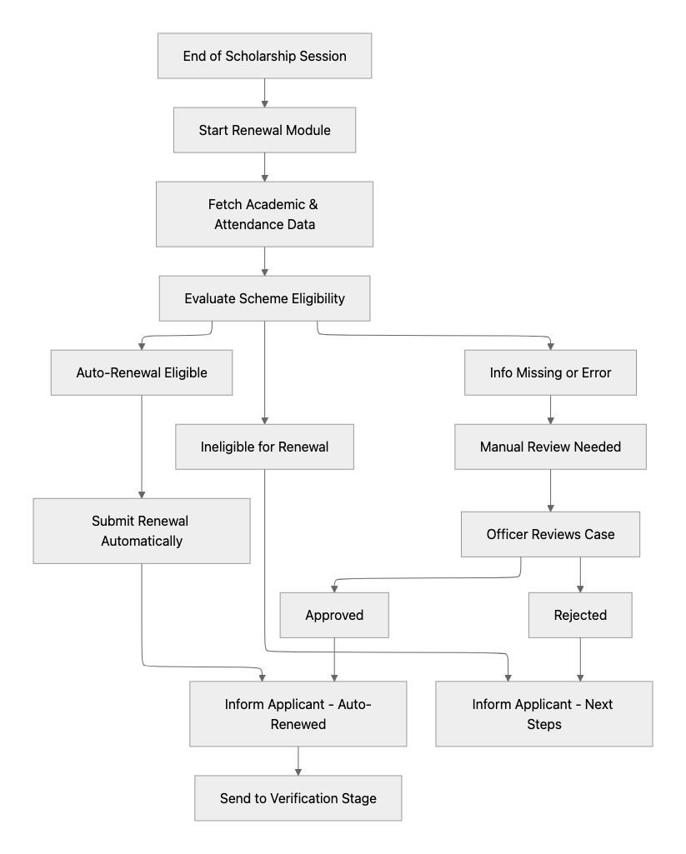

Renewal Workflow

Step 1: Trigger Renewal Cycle
- At the end of the academic session, the system flags beneficiaries for renewal.
- Candidates and institutes are notified that the renewal process has begun.
Step 2: Aadhaar-Based KYC (New Step)
- Candidates must complete Aadhaar authentication (Biometric).
- System auto-fetches updated demographic details (Name, Date of Birth, Address) from Aadhaar/Jan Aadhaar DB.
- Validates bank account seeding with Aadhaar (NPCI mapper check).
- If mismatch detected → candidate prompted to correct details before proceeding.
- Once KYC is successful, the renewal case is allowed to move forward.
Step 3: Fetch Academic & Attendance Data
- The system auto-fetches academic performance and attendance records from EMIS/ Institutes/ Boards.
- Institutes can bulk upload if API sync is not available.
Step 4: Eligibility Evaluation
- Renewal eligibility checked against scheme rules configured:
  - Minimum attendance (e.g., 75%).
  - Minimum marks/grades.
  - Income/Quota/category compliance unchanged.
Step 5: Outcome Paths
- E1: Auto-Renewal Eligible → Candidate meets all conditions.
- E2: Information Missing / Error → Missing or inconsistent data.
- E3: Ineligible → Candidate fails renewal eligibility criteria.
Step 6: Auto-Renewal Flow (E1)
- Renewal submitted automatically.
- Candidate notified (“Scholarship renewed successfully”).
- Renewal goes to the Verification Stage → onward to Finance.
Step 7: Manual Review Flow (E2)
- Officer reviews flagged applications.
- May request candidate/institute to upload missing docs (marksheets, attendance).
- Outcomes:
  - Approved → moves to Verification & Finance.
  - Rejected → candidate notified with reason.
Step 8: Rejection Flow (E3)
- Renewal marked “Not eligible”.
- Candidate notified with rejection reason (attendance, marks, income change, etc.).
- Option to reapply or explore alternative schemes.

Notifications & Alerts
Notifications ensure all stakeholders (candidates, institutes, verifiers, district/state officers, finance) are updated at every critical stage of the application lifecycle.
.
Candidate Notifications
- Submitted → Confirmation of submission, application ID.
- Query Raised (Institute/District/State) → “Additional details required. Please login and update your application.”
- Auto-renewal success or failure.
- Alert if Aadhaar renewal KYC fails
- Resubmission Successful → Confirmation of re-submission.
- Approved → Status update at each level of approval
- Forwarded → Inform that it moved to the next level.
- Final Approval Granted → “Your application is approved and marked for disbursement.”
- Rejected → “Your application has been rejected. Reason: <reason_text>.”
- Disbursement Initiated → “Funds have been sent to your bank account via DBT/PFMS.”
- Disbursement Completed → “Funds have been credited to your registered account.”
Institute Notifications
- Candidate Submission Pending Review → Notification when student submits.
- Bulk Upload Success/Failure Report → Summary of accepted/rejected records.
- Query Responses from Candidate → Institute notified when candidate resubmits.
- Escalation Alerts → If applications are pending beyond SLA.
District/State Officer Notifications
- New Batch Assigned for Verification
- Query Responses from Candidate/Institute
- SLA Alerts (X applications pending > Y days)
- Batch Approved & Sent for Disbursement
- Disbursement Confirmation / Failure Report

Admin Module to be configured for Application Management Module

Permissions
- Application Create (Self) – Candidate creates, submits or saves draft for new application.
- Application Create (On Behalf) – Institute can create, submit or save draft applications for students.
- Edit Application – Update application before submission or after query raised.
- View Application – Access full details of application.
- View Status – Track progress across workflow stages.
- Upload Student Performance - attendance/academic data
- Raise Query – Reviewer can request clarification/additional info.
- Respond to Query – Candidate/Institute can update requested fields.
- Approve / Reject / Review Application – Reviewer authority can choose applicable outcome with reason.
- Bulk Upload Applications – Institute uploads batch applications.
- Download Application Data – Export reports or records.
- Assign Applications – System admin can allocate applications to reviewers.
- View Assigned Applications – Reviewer sees only allocated applications.
- Notification Configure – Define templates & triggers for alerts.
- Role Management – Assign roles and permissions.

User Roles
- Candidate
  - Student/beneficiary who applies for scholarship, edits, submits, and responds to queries.
- Institute Application Manager
  - Creates and uploads applications for students, enters academic/enrollment details.
- Institute Verifier
  - Reviews student applications & documents at institute level; raises queries or forwards to district.
- Institute Admin
  - Manages institute users; oversees all student applications of that institute.
- District Officer
  - Verifies applications forwarded by institutes; approves, rejects, or raises queries.
- State Officer / Nodal Officer
  - Conducts final-level scheme approval; ensures quota & eligibility compliance.
- Finance / DBT Officer
  - Handles approved beneficiary list and executes disbursement via PFMS/DBT.
- System Admin (Super Admin)
  - Manages portal configuration, schemes, roles, permissions, notifications, and integrations.

Scheme Disbursement
This module is essentially the last mile of the scholarship workflow — ensuring approved beneficiaries receive designated funds through DBT/Finance system and stakeholders are kept updated.
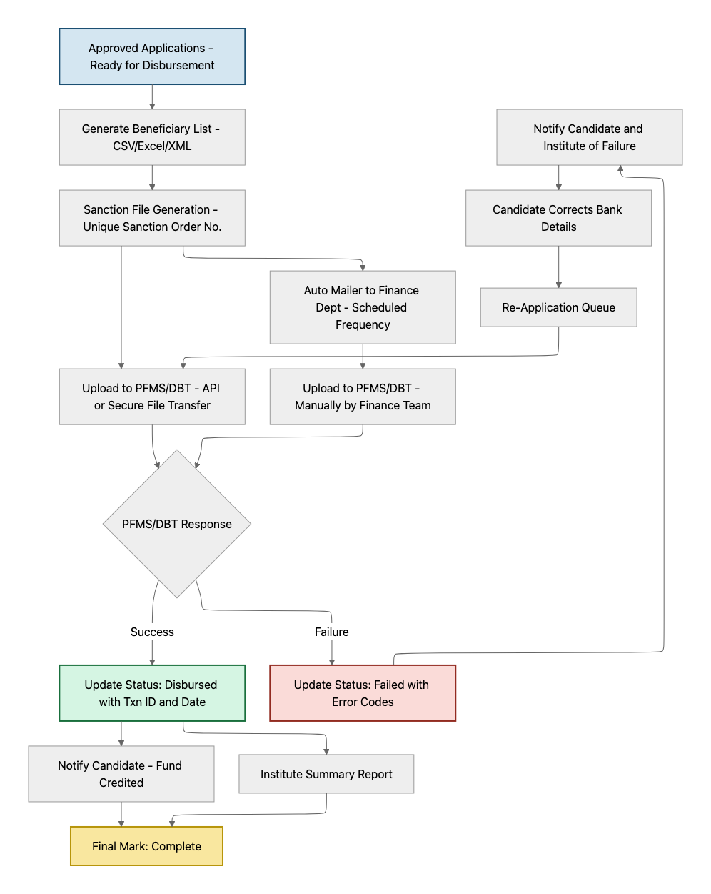

Workflow

Step 1: Beneficiary Data Preparation
- System auto-compiles all “Approved for Disbursement” applications.
- Data fields: Beneficiary ID, Name, Bank Account (validated), IFSC, Aadhaar/Jan Aadhaar, Sanction Order No., Scheme ID, Amount.
- Downloadable in CSV/Excel/XML formats compatible with PFMS/DBT.
Step 2: Sanction File Generation
- Sanction Orders are auto-generated with unique sanction numbers.
- Supports batch processing (multiple beneficiaries at once).
- Batches can be filtered by scheme, geography, or time period.
Step 3: Transmission to Finance Department
- Generated sanction files are sent to the Finance Dept (via portal + email auto-mailer).
- Finance Dept receives alerts at configurable frequency (daily, weekly, monthly).
Step 4: Finance Dept Validation
- The Finance Officer reviews the sanction file before it is uploaded to PFMS/DBT.
- Checks include:
  - Verification of scheme allocation vs. budget availability.
  - Sanction order authenticity (digital signature).
  - Bank and beneficiary data integrity.
- If Approved → file moves forward for upload to PFMS/DBT.
- If Rejected → file sent back to Scheme Admin for correction & resubmission.
Step 5: Upload to PFMS/DBT
- Approved sanction files are securely transferred to PFMS or State DBT system via API/secure file transfer.
Step 6: Acknowledgment & Status Update
- The system receives transaction reference IDs from PFMS.
- Application statuses updated as:
  - Disbursed (Txn ID, date).
  - Failed (error codes: invalid IFSC, dormant account, mismatch).
Step 7: Exception Handling
- Failed disbursements flagged for correction.
- Candidates and Institutes notified with failure reasons.
- Candidate resubmits corrected details → re-enters Finance validation → PFMS upload.
Step 8: Final Marking
- Successful disbursements are marked “Complete” in the system.
- Audit trail captured for compliance.

Integration with DBMS / Finance System
The integration will be done only to collection status of application wise disbursement

- API Integration with:
  - PFMS (Public Financial Management System)
  - State DBT platforms (e.g., Rajasthan SSO/DBT Portal)
- One-way sync: Upload of sanction lists.
- Two-way sync: Fetch of disbursement status.
- Scheduled jobs for periodic sync (e.g., every 24 hours).
- Reconciliation dashboard: compare sent vs. received vs. failed transactions.

Notifications
- Internal Notifications (Portal Users):
  - Finance Officer receives email + in-app alert when a new sanction batch is generated.
  - Scheme Admin notified on failed disbursements.
  - District/Institute officials see a summary of students disbursed under their jurisdiction.
- External Notifications (Candidates/Institutes):
  - Candidate receives SMS/Email/WhatsApp alert when:
    - Application marked as “Approved for Disbursement”.
    - Fund actually credited (with transaction ID & date).
    - If disbursement failed → instructions to correct bank details.
  - Institutes receive consolidated disbursement status reports for their students.

Users & Permissions

Permissions
- Generate Sanction Order File
- Download Beneficiary Data
- Upload Beneficiary Data to PFMS/DBT (including resubmission of failed)
- View Disbursement Status
- Reconcile Transactions (mark matched/unmatched)
- Configure Automated Mailers & Frequency
- Notification Management (Templates & Triggers)

User Roles
- Finance Officer (Dept.)
  - Generates sanction batches,
  - uploads to PFMS/DBT,
  - manages reconciliation.
- Scheme Admin (State Dept.) –
  - Oversees scheme-wise disbursement,
  - handles exceptions, reports.
- Institute Admin –
  - Views student-wise disbursement status,
  - assists students with failed cases.
- Candidate (Student) –
  - Receives status notifications; corrects bank details if required.
- System Admin
  - Configures integration, manages permissions, audit logs.

Grievance Redressal
The module will allow candidates, institutes, and other stakeholders to raise complaints or queries, track their status, and ensure resolution through a defined escalation matrix within the department.

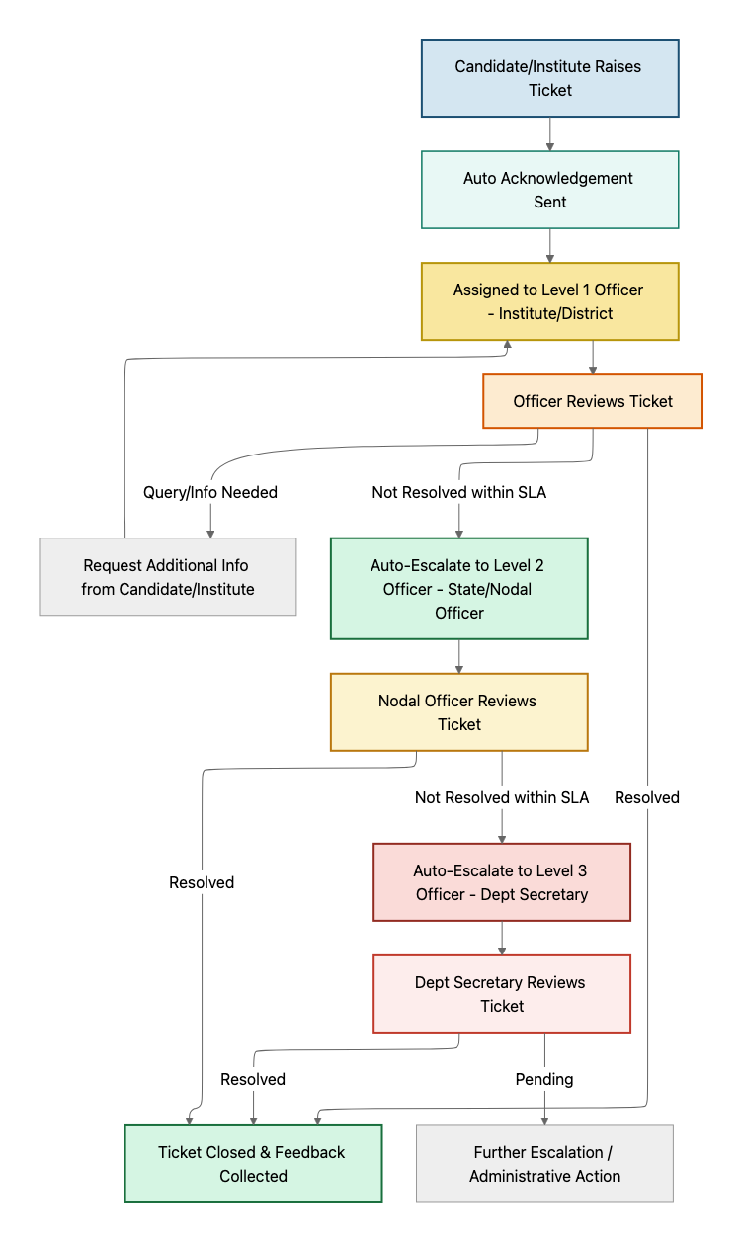

Ticketing System
- Multi-Scheme Coverage
  - Applicants can raise grievances scheme-wise (Scholarship Application, Disbursement Delay, Renewal, Eligibility Query, etc.).
- Ticket Creation
  - Candidate/Institute can log grievance via:
    - Portal (web/mobile).
    - Whatsapp
    - Chatbot on web
    - IVR
- Ticket Metadata
  - Ticket ID (unique auto-generated).
  - Applicant Details (linked with Jan Aadhaar / Application ID).
  - Scheme ID.
  - Category (Application issue / Disbursement issue / Document verification / Eligibility dispute / Technical error).
  - Priority (Normal/Urgent/High – can be auto-assigned).
- Tracking & Updates
  - Candidate/Institute can track ticket status in real-time.
  - Each update triggers SMS/Email/Portal notifications.

Escalation Matrix
- Level 1 – Institute/District Officer
  - First point of contact for verification-related or academic grievances.
  - SLA: e.g., 5 working days.
- Level 2 – Department Nodal Officer (State Level)
  - Handles escalated issues not resolved at Level 1.
  - SLA: e.g., 10 working days.
- Level 3 – Department Secretary / Higher Authority
  - Final escalation point for critical or high-priority issues.
  - SLA: e.g., 15 working days.
- Auto-Escalation Rules
  - If a ticket is not acted upon within SLA → auto-escalates to the next level with full history.
  - Notifications sent to both complainant and the escalated officer.

Notifications
- Candidate/Institute: Ticket created, under review, query raised, resolved, or escalated.
- Officers: New tickets assigned, SLA reminders, escalation alerts.
- Admins: Dashboard view of unresolved vs resolved tickets, SLA breaches, officer performance.

Admin Controls for Grievance Module

Permissions
- Candidate – Create/view ticket, add response, give feedback.
- Institute Admin – Create/view tickets for their students, upload docs.
- Officer (District/Institute) – Handle Level 1 tickets.
- Nodal Officer (State) – Handle escalated Level 2 tickets.
- Department Secretary – Handle Level 3 escalations.
- System Admin – Configure categories, SLAs, escalation rules.

Dashboards and Reporting

Role-Based Dashboards
Each stakeholder should see real-time, role-appropriate information:
- Master Dashboard
  - Beneficiary Coverage
  - Scheme Performance
  - Financial Overview
  - Quota & Equity
  - Geographic Insights
  - Grievances & SLAs
  - System Health & Alerts
- Candidate Dashboard
  - Applications: status tracker (Draft → Submitted → Verification → Disbursed).
  - Renewal eligibility alerts.
  - Disbursement history (with PFMS transaction IDs).
  - Grievance ticket status.
- Institute Dashboard
  - Pending applications (with filters by scheme/class).
  - Bulk upload success/failure logs.
  - Verification workload allocation.
  - Summary of sanctioned vs. rejected applications.
  - Disbursement summary for institute students.
- District Officer Dashboard
  - Applications awaiting verification.
  - SLA alerts (pending > X days).
  - Quota utilization (per caste/gender/income group).
  - Geo-level scheme coverage.
- State Officer / Nodal Dashboard
  - State-wide scheme analytics (applications, approvals, rejections).
  - Budget utilization vs allocation (scheme-wise).
  - Quota & reservation compliance status
  - Escalated grievances pending.

Reporting & Analytics
- Pre-Built Reports:
  - Scheme-wise coverage (no. of applicants, approvals, rejections).
  - District-wise allocation vs utilization.
  - Category-wise participation (SC/ST/OBC/Minority/Disability).
  - Drop-off points in application flow (where students exit).
  - SLA compliance reports for officers (verification, grievance resolution).
  - Finance reconciliation (budget sanctioned vs disbursed).
- Filters/Drill-Down:
  - By scheme, year, geography, income group, caste, gender.
  - Drill down from state → district → block → institute → student.
- Exports:
  - CSV, Excel, PDF for audit & review.
  - Scheduled auto-reports (daily, weekly, monthly).

Sample Dashboard Views

📊 Master Dashboard – Unified Scholarship Portal
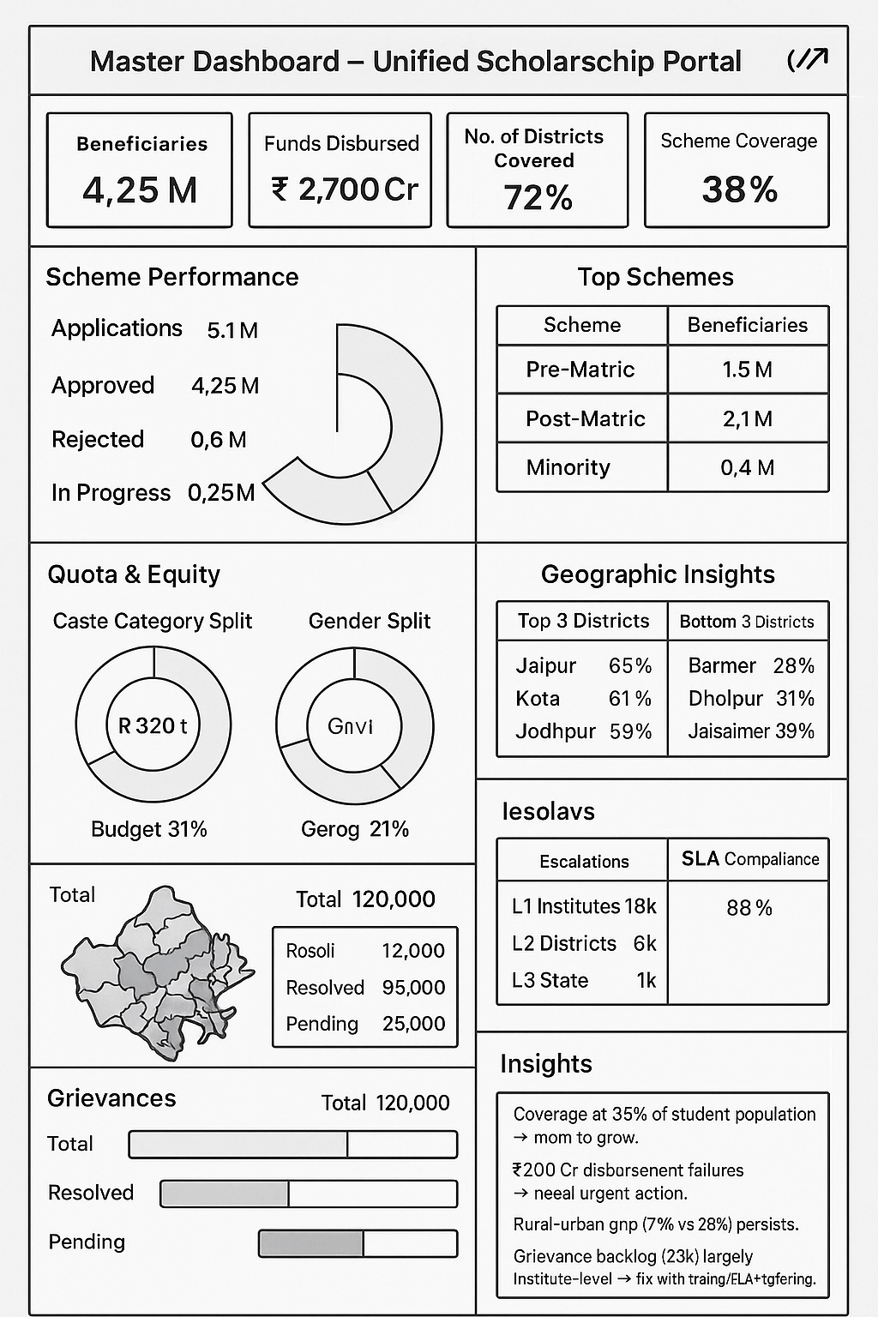

🟦 Top Strip – KPI Cards
(Displayed as 3 horizontal cards with bold numbers + small subtext)
- Beneficiaries → 4.25M
- Funds Disbursed → ₹2,700 Cr (93% of sanctioned)
- No of districts covered → 72%
- Scheme Coverage → 38% of students
- YoY Growth in disbursement → +12%

🟦 Row 1 – Scheme Performance
Left (Bar/Donut Chart):
- Applications (5.1M)
- Approved (4.25M ✅)
- Rejected (0.6M ❌)
- In Progress (0.25M ⏳)
Right (Table: Top Schemes):
Scheme | Beneficiaries
Pre-Matric | 1.5M
Post-Matric | 2.1M
Minority | 0.4M

🟦 Row 2 – Financial Overview
Visuals:
- Stacked Donut / Gauge Chart showing:
  - Budget Allocated: ₹3,200 Cr
  - Sanctioned: ₹2,900 Cr (91%)
  - Disbursed: ₹2,700 Cr (93% of sanctioned)

🟦 Row 3 – Quota & Equity
3 Donut Charts side-by-side:
- Caste Category Split
  - SC 32% | ST 18% | OBC 28% | Minority 12% | EWS 10%
- Gender Split
  - Male 52% | Female 47% | Other 1%
- Geography Split
  - Rural 72% | Urban 28%

🟦 Row 4 – Geographic Insights
Left (Heatmap): Rajasthan map with coverage % per district.
Right (Tables):
- Top 3 Districts → Jaipur 65%, Kota 61%, Jodhpur 59%
- Bottom 3 Districts → Barmer 28%, Dholpur 31%, Jaisalmer 33%

🟦 Row 5 – Grievances
Bar Chart: Resolved vs Pending
- Total: 120,000
- Resolved: 95,000 (79%)
- Pending: 25,000 (21%)
KPI Cards (Escalations + SLA):
- L1 Institutes: 18k
- L2 Districts: 6k
- L3 State: 1k
- SLA Compliance: 88%

✅ Insights Panel – Narrative Box
Plain text (bottom row):
- Coverage at 38% of student population → room to grow.
- ₹200 Cr disbursement failures → need urgent action.
- Rural-urban gap (72% vs 28%) persists.
- Grievance backlog (25k) largely institute-level → fix with training/SLA tightening.

🎯 Candidate Dashboard

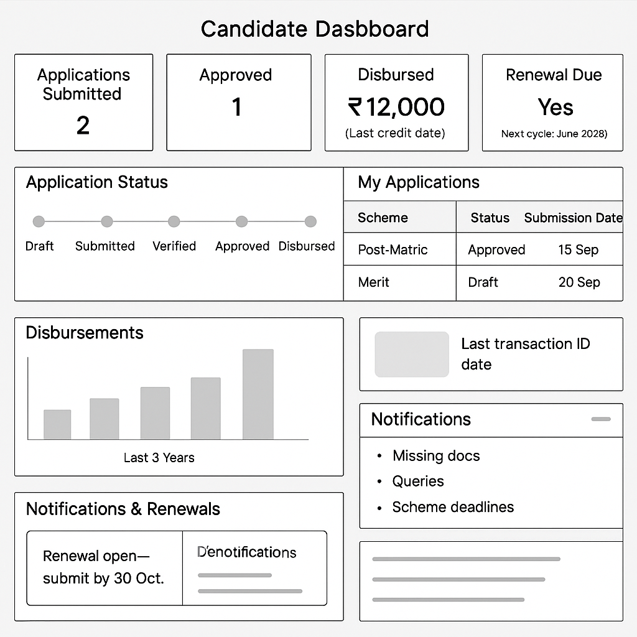

Top Strip – KPI Cards (horizontal cards)
- Applications Submitted → 2
- Approved → 1
- Disbursed → ₹12,000 (Last credit date)
- Renewal Due → Yes (Next cycle: June 2025)
- Active Grievances → 1

🟦 Row 1 – Application Status
- Left (Timeline Tracker): Draft → Submitted → Verified → Approved → Disbursed
- Right (Table: My Applications):
Scheme | Status | Submission Date | Next Action
Post-Matric | Approved | 15 Sep | Awaiting Disbursement
Merit | Draft | 20 Sep | Complete Application

🟦 Row 2 – Disbursements
- Bar/Line Chart: Disbursement history (last 3 years).
- KPI Card: Last transaction ID + date.

🟦 Row 3 – Notifications & Renewals
- Renewal Alert Card → “Renewal open – submit by 30 Oct.”
- Notification Panel (right side scroll): Missing docs, queries, scheme deadlines

🎯 Institute Dashboard

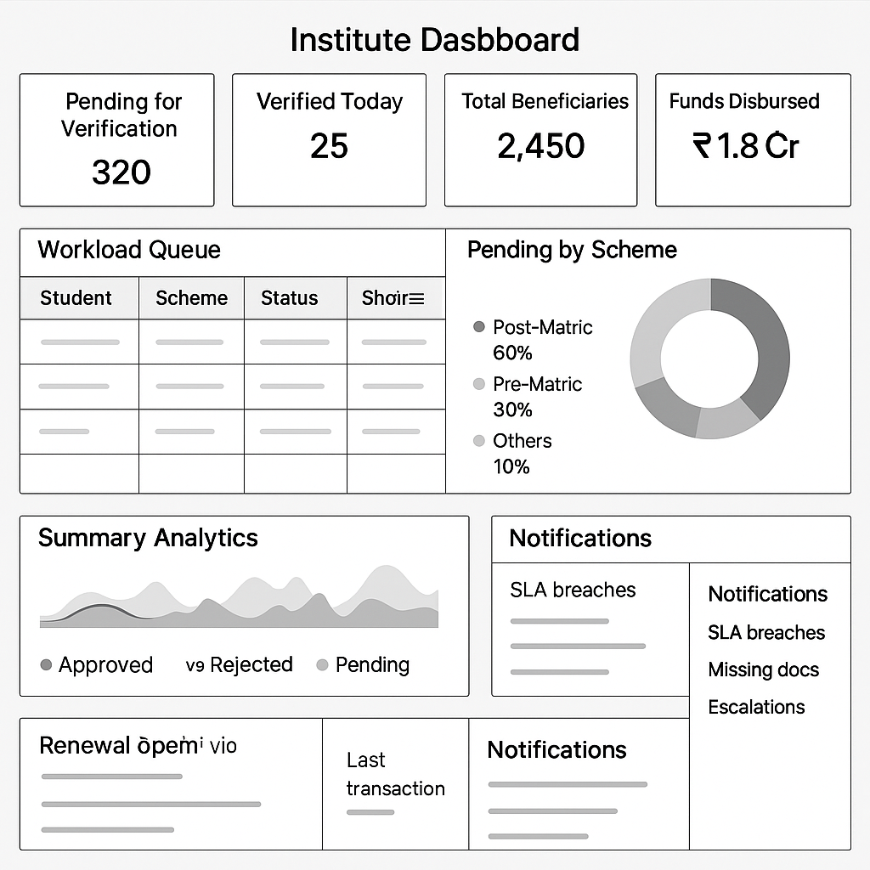

Top Strip – KPI Cards
- Pending for Verification → 320
- Verified Today → 25
- Total Beneficiaries in Institute → 2,450
- Funds Disbursed to students → ₹1.8 Cr

🟦 Row 1 – Workload Queue
- Left (Table: Verification Queue):
| Student | Scheme | Status | Submitted On | SLA Days Left |
- Right (Chart: Pending by Scheme): Donut → Post-Matric (60%), Pre-Matric (30%), Others (10%).

🟦 Row 2 – Summary Analytics
- Chart: Approved vs Rejected vs Pending trend.
- Chart: Eligible vs Ineligible ratio.

🟦 Row 3 – Disbursements & Alerts
- Table: Disbursement summary (Student, Scheme, Amount, Date).
- Notifications panel: SLA breaches, missing docs, escalations.

🎯 District Officer Dashboard – Visual Brief

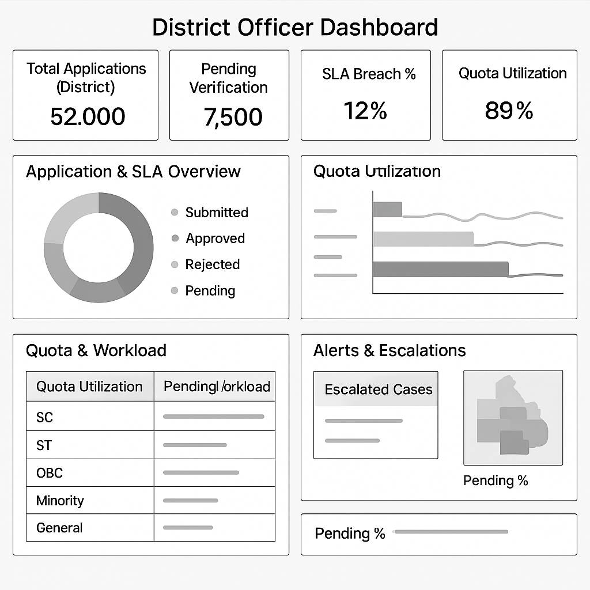

Top Strip – KPI Cards
- Total Applications (District) → 52,000
- Pending Verification → 7,500
- SLA Breach % → 12%
- Quota Utilization → 89%
- Disbursed Amount → ₹64 Cr

🟦 Row 1 – Application & SLA Overview
- Donut Chart: Submitted vs Approved vs Rejected vs Pending.
- Bar Chart: SLA compliance trend per week.

🟦 Row 2 – Quota & Workload
- Stacked Bar: Quota utilization (SC/ST/OBC/Minority/General).
- Table: Top institutes with pending workload.

🟦 Row 3 – Alerts & Escalations
- Panel: Escalated cases requiring district officer intervention.
- Heatmap: District sub-blocks with highest pending % (optional if geo granularity available).

✨ Layout Style Recommendation (All Dashboards):
- Top Strip: Always KPI cards with large bold numbers.
- Row 1–2: Operational stats (applications, performance, verification).
- Row 3–4: Financials, quota, equity, geographic coverage.
- Bottom Panel: Notifications / Escalations / Insights.

🎯 State Officer (Nodal) Dashboard – Visual Brief

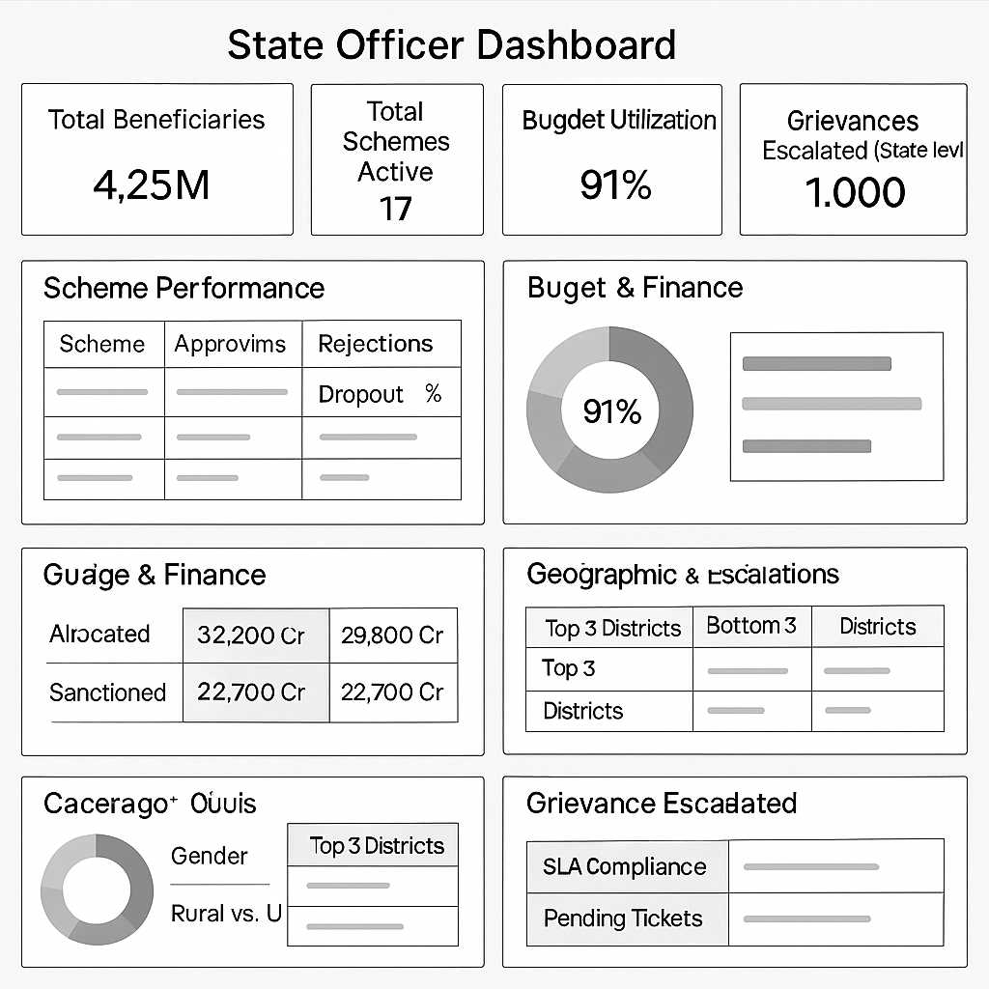

Top Strip – KPI Cards
- Total Beneficiaries → 4.25M
- Total Schemes Active → 17
- Budget Utilization → 91%
- Disbursed → ₹2,700 Cr
- Grievances Escalated (State level) → 1,000

🟦 Row 1 – Scheme Performance
- Left (Scheme Cards Grid): Each scheme → Applications, Approvals, Rejections, Dropout %
- Right (Bar Chart): Top 5 schemes by beneficiaries.

🟦 Row 2 – Budget & Finance
- Gauge/Stacked Donut: Allocated ₹3,200 Cr → Sanctioned ₹2,900 Cr → Disbursed ₹2,700 Cr.
- Line Chart: Year-on-year growth in disbursements.

🟦 Row 3 – Quota & Equity
- Three Donut Charts side-by-side:
  - Category (SC/ST/OBC/etc.)
  - Gender split
  - Rural vs Urban coverage

🟦 Row 4 – Geographic & Escalations
- Heatmap: District-wise coverage % and funds.
- Right (Tables):
  - Top 3 districts (coverage %).
  - Bottom 3 districts (coverage %).
- Grievance Escalation Panel: SLA compliance + pending tickets by L1/L2/L3.

✨ Layout Style Recommendation (All Dashboards):
- Top Strip: Always KPI cards with large bold numbers.
- Row 1–2: Operational stats (applications, performance, verification).
- Row 3–4: Financials, quota, equity, geographic coverage.
- Bottom Panel: Notifications / Escalations / Insights.

Public Pages

Pages
Priority 1 & 2
Website Home Page
Schemes List Pages
Application Approval Pages
Priority 3+
User Profiles Page
Scheme Application Page
User Application Status Page
Live Dashboard (KPIs to be decided with stakeholders)
Grievance Ticketing and Status Page
Page Index
Dynamic/Static

Each Module to have
- Doctype
  - Naming Rule
  - Fields
  - Link
  - Forms
  - Workflows
  - Notification Rules
- MetaData Tables Structure
- Public Pages Links

Product Concept Note



Product Concept Note
Unified Scholarship Interface (USI)

Table of Contents
Purpose 2
Components of the Scholarship Model 2
Design Philosophy 2
Product Modules 2
Modules Details 5
MVP Proposal 9
Product Wireframes 9
Implementation Roadmap 12
Phases Summary 12
Risk & Mitigation Strategy 12
Key Risks & Challenges 12
Mitigation Plan 13

Purpose
To create an integrated, technology-driven platform that streamlines discovery, access, application, verification, and disbursement of scholarships improving coverage, efficiency and transparency.

Components of the Scholarship Model

Design Philosophy
The design of the product should enable the various state governments to install and configure the product in their ecosystem seamlessly. Below are the principal components of design philosophy:
- Configurable scholarship module through which different types of scholarship can be defined
- Configurable eligibility and disbursement modules
- Both cloud and on-prem hosting support. On-prem hosting within state’s Local data center (on-premise) would enhance data protection and compliance management
- Ability to map the students’ educational journey to enable administrative efforts in ensuring benefits to all eligible students
- Allow for auto - renewal process which will remove burden to application from students every year
- Dashboard and reports bundled as part of the product

Product Modules
There will be 8 modules of the product to cover (excluding Front End UI/UX) - Login Flows, Application and Disbursement flows, Grievance Redressal and Monitoring. These are as below:

Module Name | Sub-Modules
Public Pages | Website pages  Profiles Pages  Application flows  Ticketing flows  Live Dashboard (KPIs to be decided with stakeholders)
Candidate Management | Login Flows  Basic Profile  Scholarship History  Academic History (APAAR ID)  Grievance History
Scheme Management | Adding and Modifying Schemes  Eligibility Engine Config
Application Management | Application Verification Module  Renewals Module (incl auto renewal)  Custom application verification flows for different scholarship types
Disbursement Module | Disbursement process  Accounting process
Grievance Redressal | Grievance Management (ticket system)  Virtual support bot  Voice call integration
Monitoring & Reporting Dashboard | User Academic Journey Map  Beneficiary Dashboard  Post-Scholarship Outcome Tracking
Integration | Integration with Digilocker, RTE DB  DBT and PFMS Integration  Physical Transfer (UPI/NEFT/cheque)
Admin Module | Manage access control  SLA configuration  Notifications and Alerts

PILOT Proposal

Questions that we need to answer before pilot kick off
- Would the pilot manage only new scholarships or also take over managing existing ones?
- Which State do we do the pilot in? Any specific region or district within the state?
- What are the success criteria for the pilot and exact deliverables?
- Will the States have student’s data already available which can be accessed by our tool through an API or a data connector during the pilot
- Is the Eligibility criteria (e.g., income thresholds, caste categories) expected to change significantly during the pilot
- Will the Schools have reasonably updated records with relevant state MIS databases to enable class-wise mapping to get results and attendance
- Will there be district/block-level officers who can verify, approve, or escalate applications within the system.
- Will we have opportunity to take feedback from Stakeholders (students, teachers, dept officers) for future phases and iterations
- What are the SLAs to be configured in each stage of application process?

MVP Proposal
- Public Pages
  - Website page
    - Rajasthan - Potential of use RajShalaDarpan
    - Meghalaya - No scholarship interface, we will need to create a new one
  - Application flow
    - Build a simple application form with custom fields and document requirements basis applicable scheme

- Candidate Management
  - Login Flows
    - Rajasthan - Potential to utilise RajSSO and link to Raj ShalaDarpan
    - Meghalaya - Build New. No existing login or scholarship portal.
  - Application Status Page
    - Build a simple application status page configured for each scheme basis scheme requirements and documentation needed from the student
    - The design will be desktop friendly given it will also be an assisted process

- Scholarship Management
  - Adding and Modifying Schemes
    - Add all existing schemes from backend for the pilot in the portal
  - Eligibility Engine Config
    - Use the IA eligibility engine already available with required configuration changes basis the schemes available in the state

- Application Management
  - Application Verification Module
    - Create an interface to process all applications received
    - Identify which aspects of verification will be automated. E.g. all docs available on Digilocker can be auto verified
    - Identify the Manual verification parts in the process with POC / team from state govt and create an interface for them to verify

- Disbursement Module
  - Disbursement through API calls or data input to external payment system
  - Actual integration with DBT / PFMS system may be done in post pilot phases if agreed with the state authorities

- Monitoring & Reporting Dashboard
  - Beneficiary Dashboard will be created for the state hosted on Superset
  - Training with govt stakeholders to be done on how to view and read Superset dashboards
  - Integrated dashboards in post pilot phases

- Integration
  - Integration with Digilocker for PII verification
  - Meghalaya
    - Integration with e-District Meghalaya for family related info (caste, income, residential Certificates)
    - MBOSE + Education Dept MIS + UDISE for student info (school marksheets, attendance)
  - Rajasthan
    - Integration with Jan Adhaar for family related info(caste, income, residential Certificates)
    - Rajshala Darpan + RT database + UDISE for student info (school marksheets, attendance)
    - Integration into current scholarship process

Pilot Plan of Action
Action | Details | Timeline
Discovery and Fact finding | - Immerse with state govt to understand current working structure  - Identify existing systems to integrate  - Define POCs for the pilot who will run the various steps in the process  - Define details of region/district where pilot is to be done | 4-5 weeks
Initial Development | - Built the MVP modules as per above  - Integrate with govt systems for data input  - Train the POCs to run the new system | 8-10 weeks
Feedback Mechanism and Iterations | - Take feedback from users and internal POCs to identify any enhancements / improvements in the defined MVP  - Implement the P0 iterations and continue the feedback process | Post MVP Implementation till pilot closure
Tracking of success metrics | Track the pre defined metrics in the new portal  Monthly check in with state dept leadership | Post MVP Implementation till pilot closure

Modules & Data Workflows

Data Flow

Sub-Module | Suggested Data Tables | Purpose
Document Repository | Add a user_documents table | Store ID/income/caste certificates with upload status & verification flag
Manual Verification Workflow | Add a verification_cases table | Track manually flagged users, decision history, timestamps
Audit Logs | Add user_action_logs, system_event_logs | Trace user activity and system-level operations for transparency
Notification System | Add notifications and user_notifications_log | Track emails/SMS for each user (e.g. status updates, reminders)
Scholarship Programs | scholarship_programs, program_fund_ledger | Allow multiple funds, caps, deadlines, type classification
Session Tracking | user_sessions | Secure user login tracking, including roles, duration, IP
Outcome Tracking | Consolidate under scholar_post_outcome | Use APAAR ID or linked records to track employment, further studies, etc.

The data information flow will take place as below:
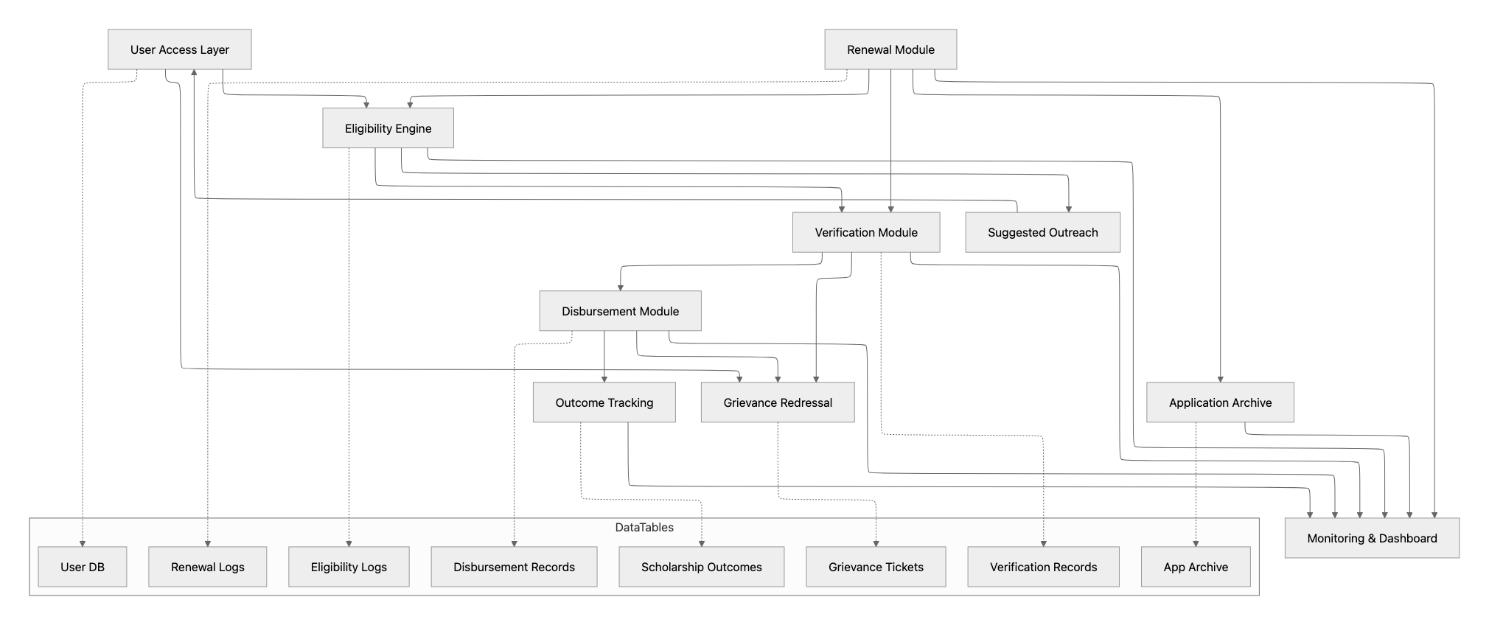

Modules Details
- Candidate Management
  - A single mobile/web interface where students can discover all scholarships schemes provided by the state govt
  - Multilingual and mobile-friendly
  - Will have the Interface for Application flow for all schemes
  - View all application and service request history on the profile page
  - Benefits:
    - Simplifies discovery for students increasing visibility of lesser-known scholarships while reducing application efforts.
    - One place for govt officials to approve and process the entire application flow till disbursement

- Scholarship Management
  - Plug in IA Eligibility Engine to pre-map students to schemes based on their information in the system.
  - Link with Aadhaar-linked profiles, Digilocker, academic record, caste/income data, and location with state govt databases
  - Benefits:
    - Applicants complete the process in a single portal (minimizing friction).
    - Eligibility Engine automates most decisions, but edge cases are safely routed for human review.
    - Recommendation Engine democratizes access by surfacing additional opportunities for eligible students, boosting inclusivity.
    - Audit, fraud, and data privacy - improving compliance and trust.
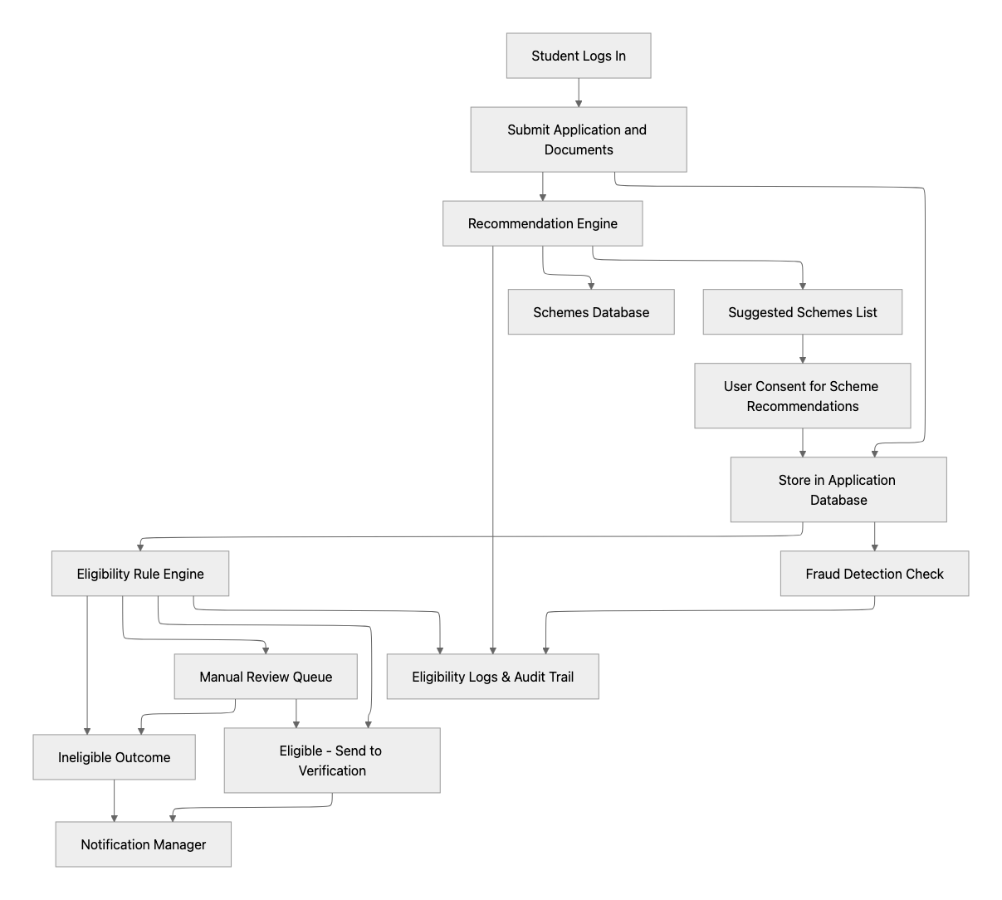

- Application Management
  - Verification Module
    - Students verified via DigiLocker, Aadhaar e-KYC, or institute nodal officer approval.
    - All entities use the same verification protocols wherever possible.
    - Benefits:
      - Standardizes and expedites verification
      - reduces fraud due to common database verification
      - builds trust across stakeholders
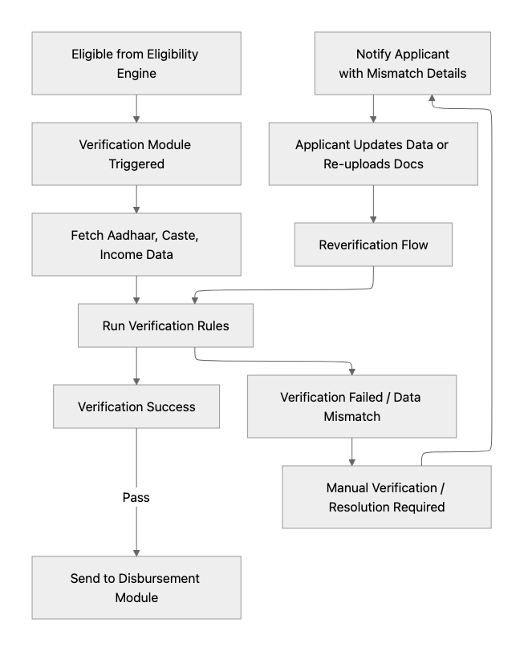

  - Renewal Module
    - Tracks the academic and attendance status of the beneficiary student and auto applies for renewal
    - Renewals also go through the same process as new application for verification and disbursement to ensure accuracy of model
    - Benefits:
      - Continuity of education for deserving students
      - Better experience for students in not having to go through the application process again
      - Efficient Welfare scheme implementation by govt

- Disbursement Module
  - Scholarship disbursement via DBT/PFMS.
  - Option to also integrate with secure payment gateways or bank APIs.
  - Optional use of NPCI-backed payment rails (UPI Autopay, Aadhaar Pay).
  - Benefits:
    - Ensures timely, traceable payments
    - minimizes leakages and manual processing errors
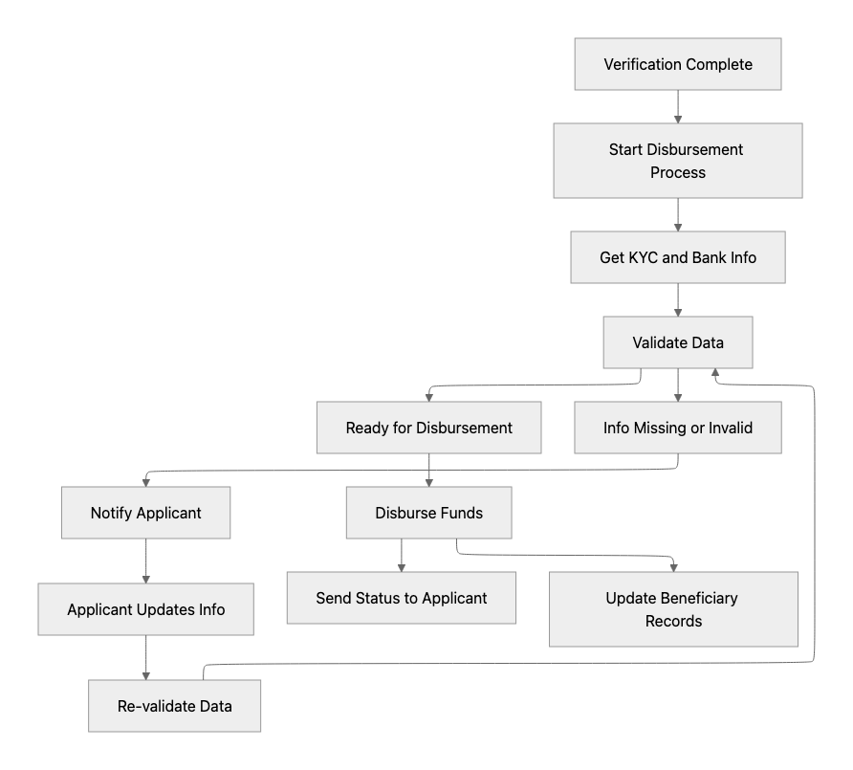

- Grievance Redressal Layer:
  - Unified ticketing system across schemes and applicants
  - Escalation matrix in the dept to ensure timely resolution
  - Benefits:
    - Ensures faster resolution and transparency
    - Strengthens accountability
    - Improves student satisfaction

- Monitoring & Reporting Dashboard:
  - Real-time analytics on application volumes, fund disbursal and renewal efficacy
  - View or Edit access for ministry depts and other stakeholders
  - Benefits:
    - Informs policy decisions
    - enables data-driven governance

- Post-Scholarship Outcome Tracking:
  - Systematically track the academic and possibly employment progress of scholarship recipients after completing their programs.
  - Data points include school results, higher education and employment status
  - Benefits: O
    - Validates effectiveness of schemes through long-term impact measurement
    - Helps design better-targeted interventions and improves accountability

Implementation Roadmap

Phases Summary
Module Name | Phase 2 | Phase 3 | Phase 4
UI/UX Layer | Ticketing flows | Profiles Page
User Access Layer | Admin Control  Access Manager | Profile Management
Eligibility Engine Integration | Matching Rule Engine for recommendations
Verification Module
Disbursement Module |  | Physical Transfer (UPI/NEFT/cheque)
Renewal Module | Rule based Auto Renewal mechanism
Grievance Redressal | Grievance Management (ticket system) |  | Virtual support bot
Monitoring & Reporting Dashboard |  | User Academic Journey Map (APAAR ID)
Post-Scholarship Outcome Tracking |  |  | Impact Measurement Dashboard

Implementation Timeline
Phase | Details | Timeline
MVP | Basic Scholarship Management System | Sep 2025 - Dec 2025
2 | Recommendations, Renewal Mgt & Grievance Mgt | Jan 2026 - Feb 2026
3 | Profile Mgt, Student Journey Map | Mar 2026 - Apr 2026
4 | Virtual Support & Impact Measurement | May 2026 - Jun 2026

Risk & Mitigation Strategy
Risk | Details | Mitigation Plan
Data Privacy and Security Risks | Sensitive information of students and families risk leakage to other external platforms | Use data masking, host platform on local server. Conduct regular third-party security audits.
Applicant Awareness | Low visibility in remote districts; reliance on partner NGOs for outreach | Use existing govt channels to ensure awareness through all schools & community channels
Data availability for the scholarship System | Demographics, Family ID (parents' profession, sibling, KYC, bank details) and Education (marks, attendance) | Ensure all data access is available to the locally hosted platform
Duplication of Benefits | Students receiving multiple overlapping scholarships. | Implement de-duplication using Aadhaar and maintain a central benefit ledger
Governance and Accountability Conflicts | Disputes over responsibility for grievances or delays. | Define SLAs, use a unified grievance redress system with escalation paths, and form an oversight board

Product Wireframes

Applicant Interface

Home Page

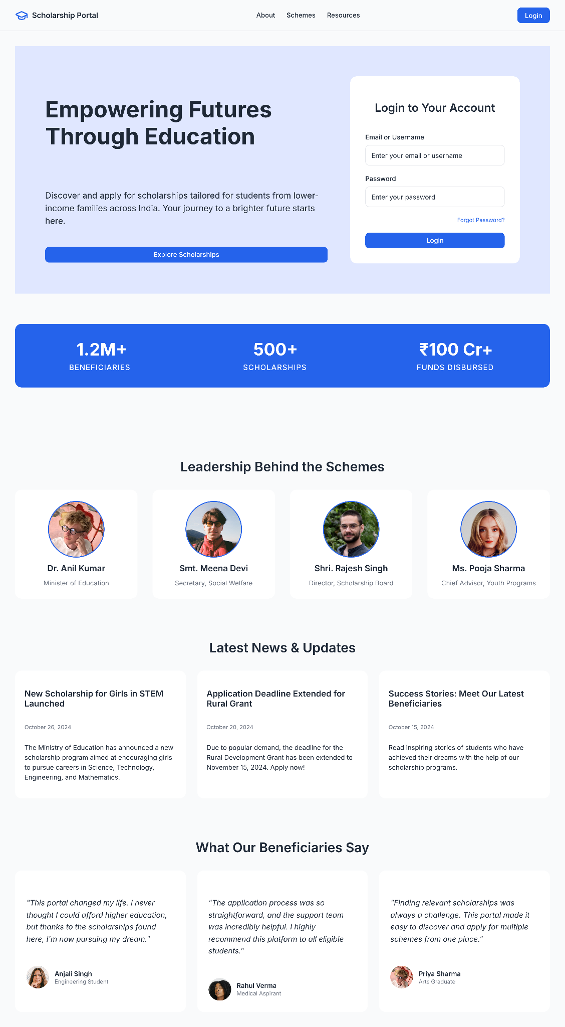


Login Page
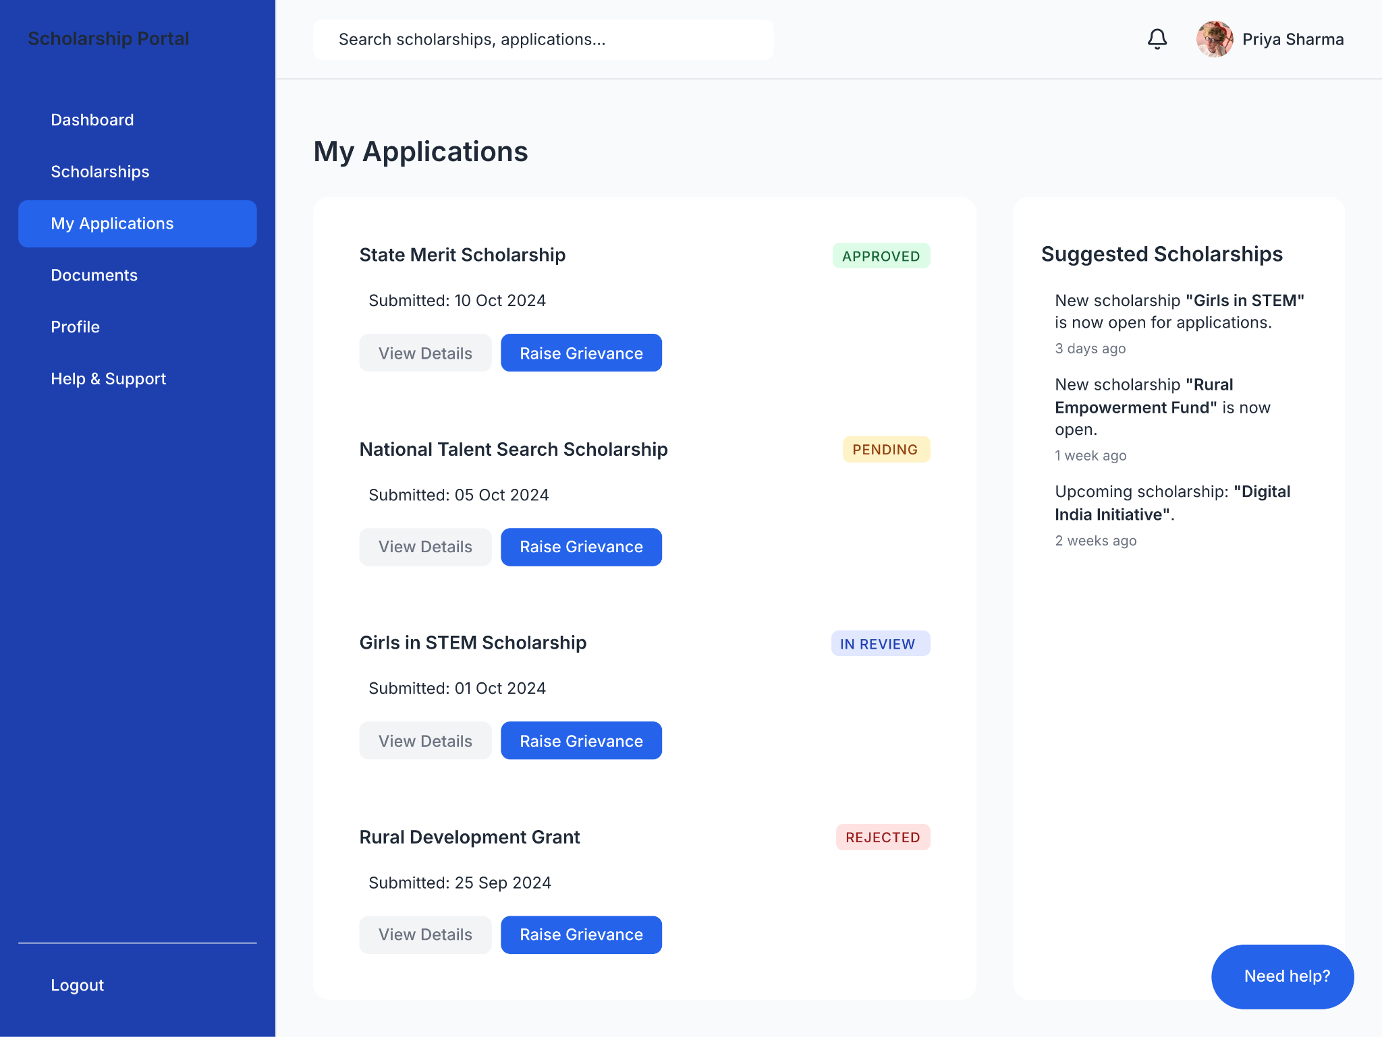

Grievances Page
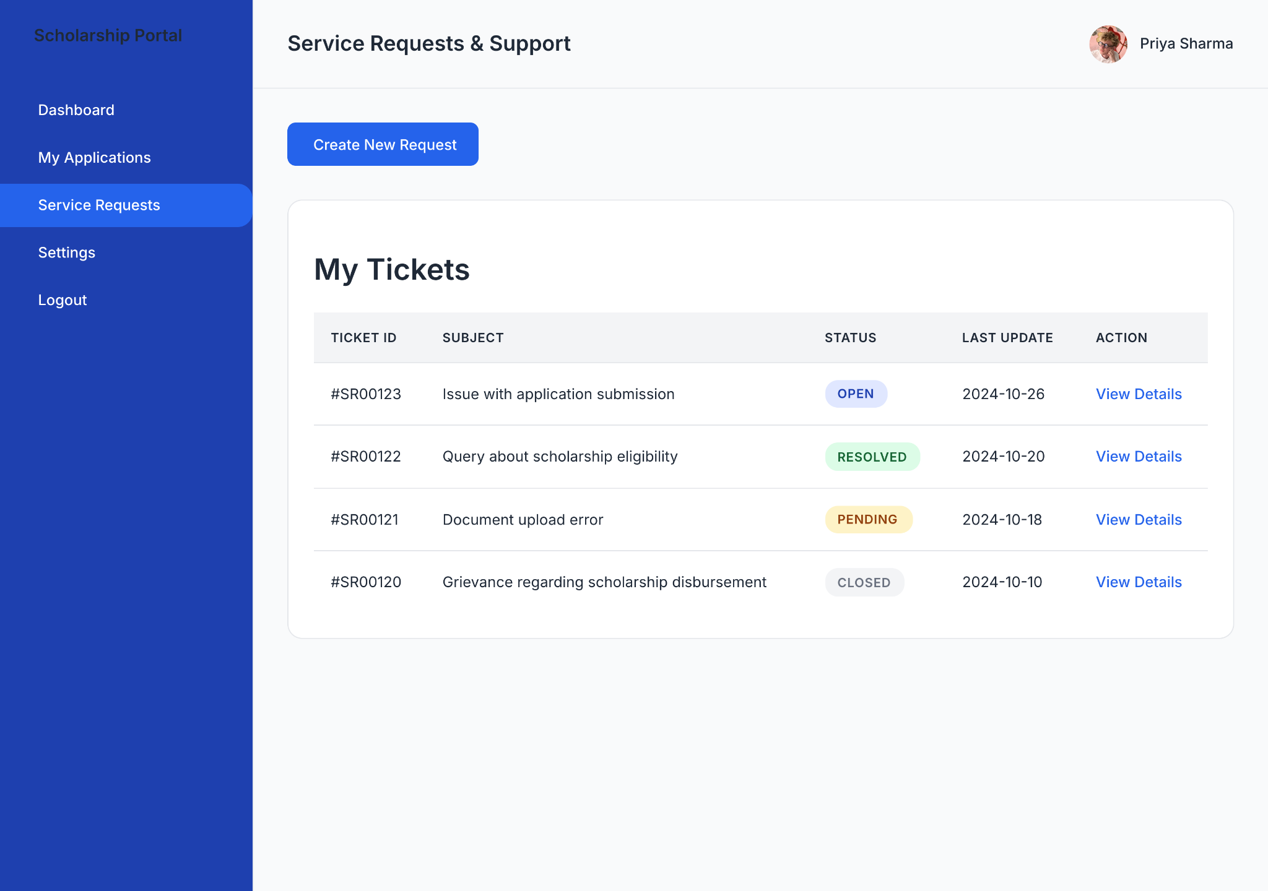

Govt Interface

Application Dashboard
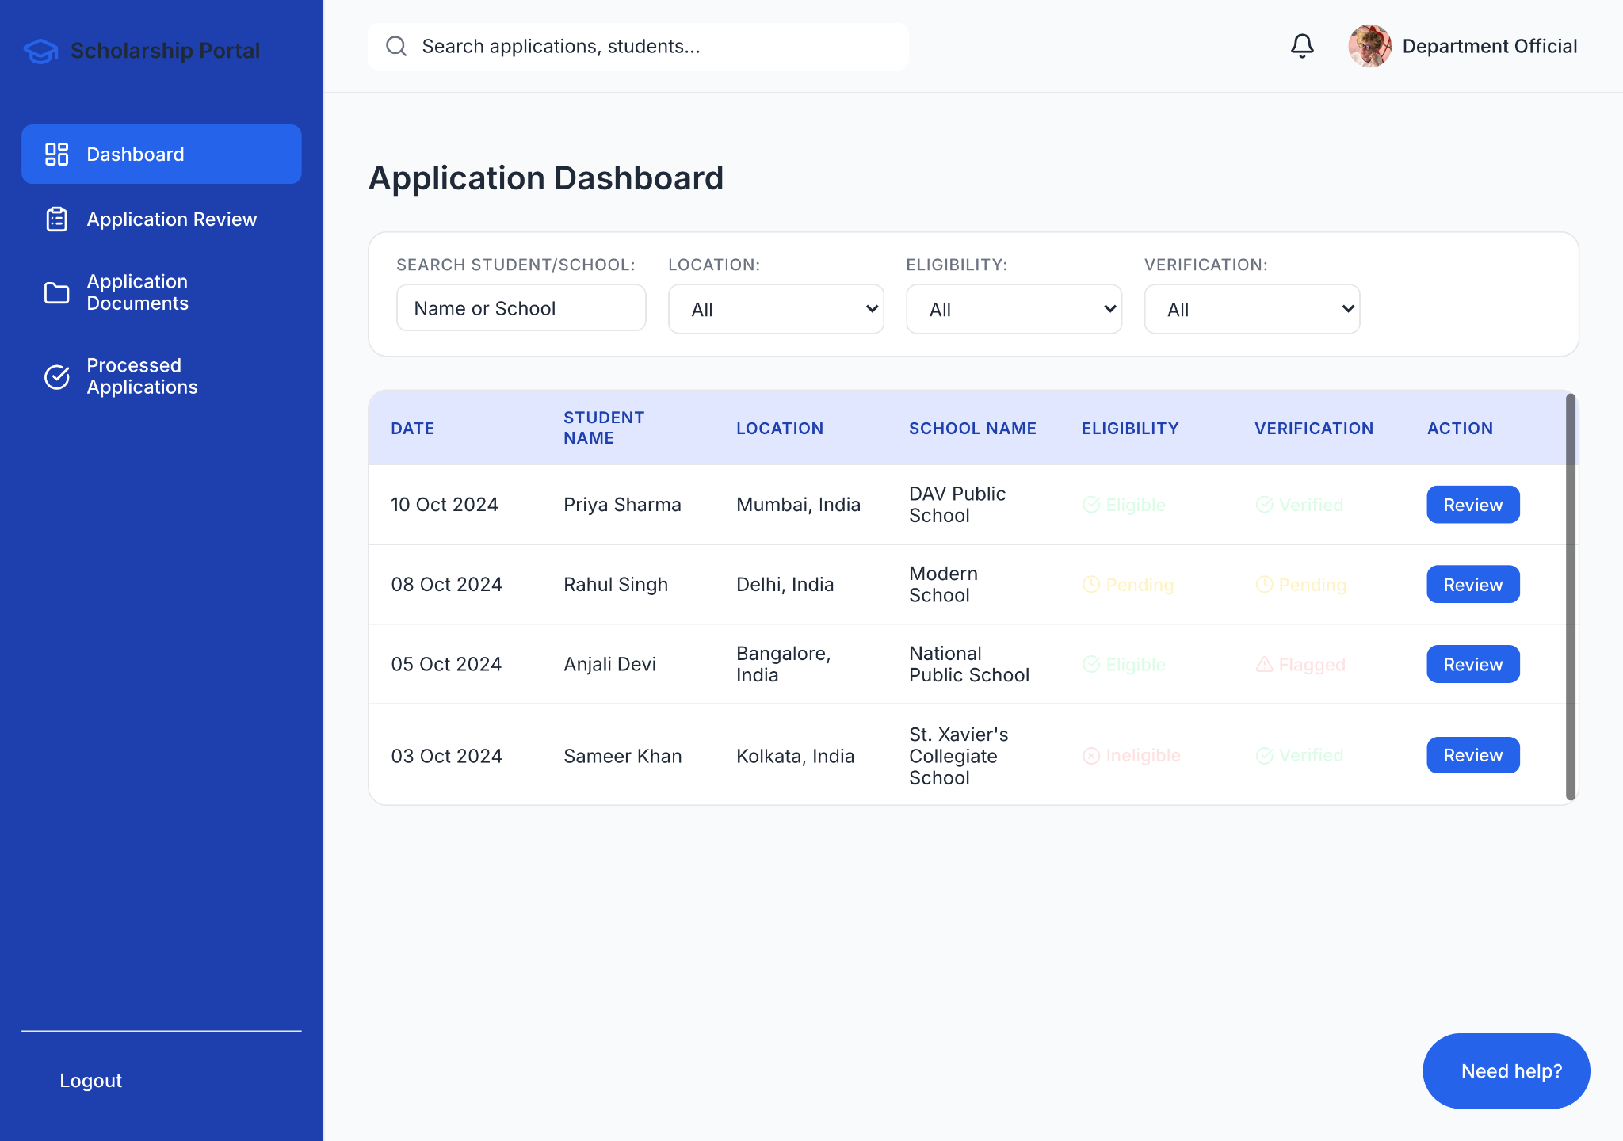

Application Review
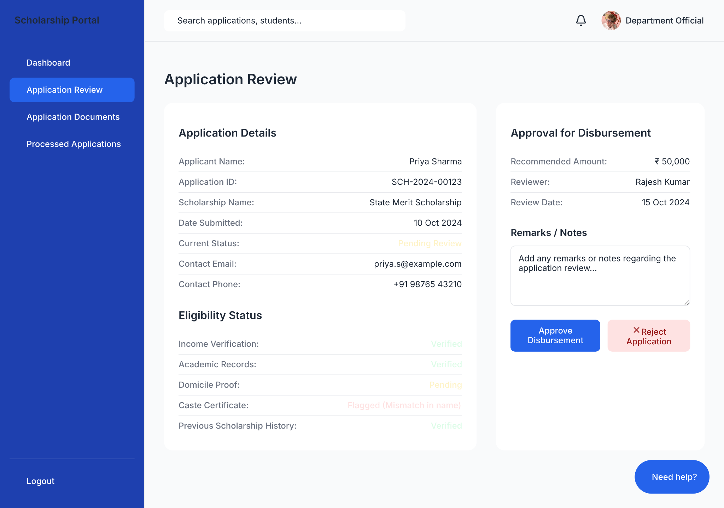

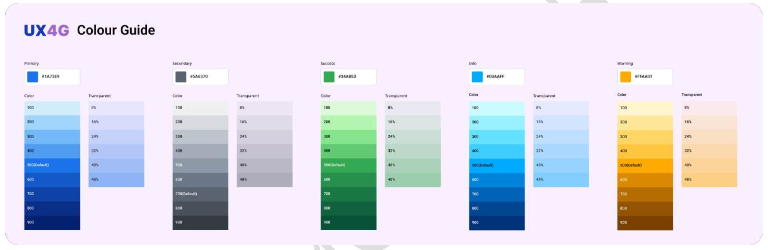
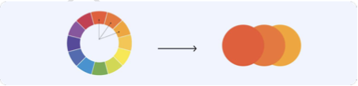

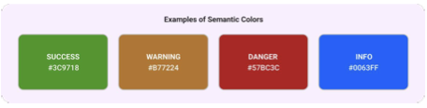
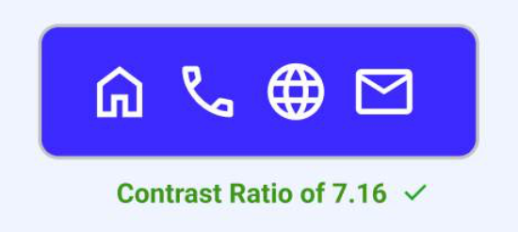

https://fonts.google.com/icons

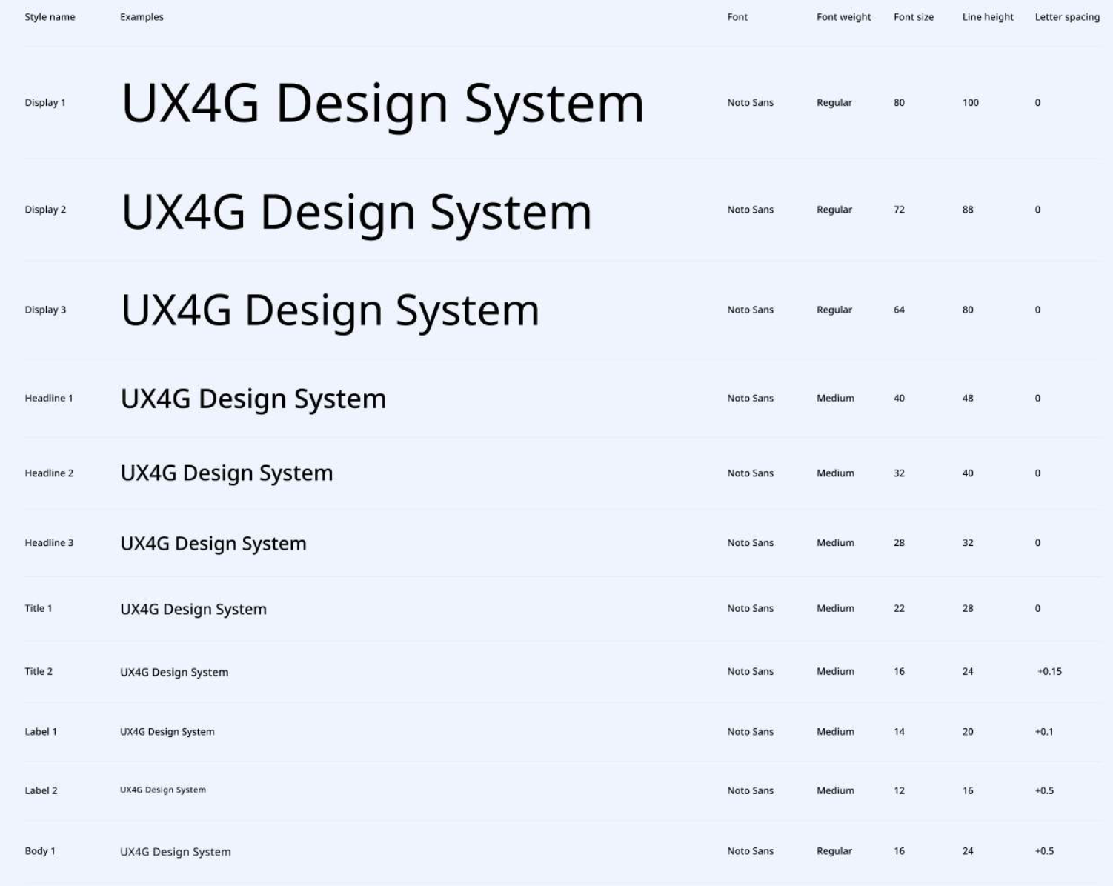

Important Pages
Page 44 - Mobile Application points
Page 71 - About Us structure
Page 82 - Login and Signup using National Single Sign-On
Page 85 - Search Functionality
Page 97 - Forms and Data Entry
Page 113 - Offline Functionality
Page 122 - Suggested Third-Party Tools
P[age 134 - Accessibility
Page 146 - Footer
Page 149 - Navbar
Page 158 - Mobile Application Patterns

